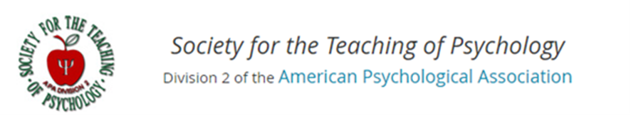

Instructional Resources for Psychology

Teaching Communication and Scientific Literacy through Digital and Social Media
Kameko Halfmann¹ & Jake C. Kurczek²
¹University of Wisconsin - Platteville; ²Loras College

Author Note

¹Department of Psychology, University of Wisconsin - Platteville, Platteville, WI 53818

²Departments of Neuroscience and Psychology, Loras College, Dubuque, IA 52003

Supported by a 2017 Instructional Resource Award to Kameko Halfmann and Jake C. Kurczek.

Correspondence may be addressed to Kameko Halfmann, Department of Psychology, University of Wisconsin - Platteville, One University Plaza, Platteville, WI 53818. Tel: (608)342-1695. Email: halfmannk@uwplatt.edu

Copyright 2018 by Kameko Halfmann & Jake C. Kurczek. All rights reserved. You may reproduce multiple copies of this material for your own personal use, including use in your classes and/or sharing with individual colleagues as long as the author’s name and institution and the Office of Teaching Resources in Psychology heading or other identifying information appear on the copied document. No other permission is implied or granted to print, copy, reproduce, or distribute additional copies of this material. Anyone who wishes to produce copies for purposes other than those specified above must obtain the permission of the authors.

Empirically-Supported Teaching Strategies Utilized in this Resource
Written communication is a top priority for colleges and universities and for the American Psychological Association (APA). Each of the outlined assignments includes a writing component, with a specific audience and purpose. Writing, in general, gives students a chance to reorganize information in their own words, which can enhance conceptual understanding of material through deeper processing. This practice is also a form of elaborative rehearsal. Students who complete short writing assignments that vary in type and content tend to perform better on exam questions (Nevid, Pastva, & McClelland, 2012). Writing for social media provides students an opportunity to both rehearse material in class and practice writing for a tangible audience. In our resources, we also emphasize two writing best practices that are often less prominent in traditional writing assignments: practice paraphrasing and instructing students on different kinds of sources (i.e., information literacy; Ishak & Salter, 2017).
In addition to writing, we discuss the role of feedback in our resources. Feedback is important to student learning and is most effective when given as soon as possible (Brinko, 1993). The outlined assignments each incorporate and provide unique opportunities for timely feedback from both the instructor and peers. For example, microblogging on Twitter gives the instructor and other students the chance to provide timely positive reinforcement (via “likes”) for quality contributions and responses to questions. Similarly, we discuss a schedule to implement deadlines for an electronic portfolio assignment, including recommendations on providing timely feedback to support student learning.

Teaching Scientific Literacy and Public Engagement with Social Media
The first question many instructors might ask is why should we engage students in social and digital media assignments? We often view social media as something we use for keeping up with friends and family. And our students are on social media all the time for non-academic purposes. So what purpose does it serve in higher education? Social media is engaging and often rewarding to students. Therefore, as instructors, we have an opportunity to hijack student attention using social media as mechanism to enhance student written communication, elaborative rehearsal, information literacy, course relevance, and motivation.
Why should we use social and digital media in a psychology course, more specifically? We argue that adopting digital and social media in higher education may be especially important in psychology, which is often portrayed pseudoscientifically in popular media. For example, the term “neurobabble” was coined (Muzur & Rinčić, 2013) to describe individuals’ tendency to trust psychological research more if the description is paired with a picture of the brain. Psychological science is frequently oversimplified and presented in an eye-catching way to the public, often times missing the intent of the original research. In fact, sometimes pop psychology articles completely misrepresent scientific literature. Engaging students in guided social and digital media projects gives the instructor the chance to help students discern credible versus non-credible sources, enhances the delivery of content, and helps students develop 21st century skills (such as critical thinking and creative thinking). In other words, guiding our students to be scientifically literate, or able to understand scientific concepts, also involves guiding our students through popular media rather than ignoring digital media or categorically excluding it from analysis.
In fact, several scientific​ ​organizations,​ ​including​ ​the​ ​American Psychological Association (APA),​ ​suggest​ ​using​ ​technology​ ​in​ ​science​ ​courses to​ ​help​ ​students​ ​appreciate​ ​how​ ​technology​ ​affects​ ​scientific​ ​advancements​ ​(e.g.,​ ​AAAS,​ ​1993; NRC,​ ​1996;​ ​APA,​ ​2007).​ Similarly, Krause (2013) discusses the importance of “civic” scientific literacy and the ability to understand and apply scientific concepts when reading news media. ​
For example, digital media projects such as an Electronic Portfolio are indicated as a high impact practice, meaning they have been shown to improve student learning in higher education (AACU, 2008). The assignments outlined below offer examples for how instructors can incorporate social and digital media through in-class activities (visitor-and-resident mapping), small assignments (e.g., microblogging on Twitter), and large assignments (such as an e-portfolio using Wordpress). Some of these activities are well suited for any class size, level, or medium (e.g., face-to-face or online), such as microblogging on Twitter. Others are better suited for smaller, upper level courses, such as creating an E-portfolio. Through these activities and assignments students will develop critical thinking skills and communication skills.
Throughout the assignment resources, we also point to methods to maximize privacy or implement the assignment using the course learning management system (LMS) instead of directly on social media, when possible. There are advantages and disadvantages to using a social media platform relative to an LMS, and we discuss these at various points in this resource guide.
Creating diverse personal learning networks using digital and social media
Social and digital media affect how we operate as a society and, therefore, how students develop into globally engaged and culturally aware citizens. For example, knowledge is becoming a more accessible, collective agreement subject to social review (Greenhow & Gleason, 2014). Rather than bestowing knowledge on students, we aim to facilitate inquiry (Barczyk & Duncan, 2013; Newman & Scurry, 2015). Although students use technology frequently and are often referred to as “digital natives” (Prensky, 2001), the Education Center for Analysis and Research (ECAR) suggests student tech use is broad, not deep. Moreover, ECAR’s 2016 report indicates students still need support to use technology in a useful way (Brooks, 2016).
The increased need to prepare students for a digital society comes in parallel with two pedagogical trends: providing more interactive activities and providing community engagement opportunities (AACU, 2012). Marrying social/digital media with hands-on activities or community engagement presents an avenue for high impact practices that students can readily apply.
Moran, Seaman, and Tinti-Kane (2011) suggest social media can be especially valuable for collaborative learning. Social networks can be used to create collaborative communities among classmates and to build communities that persist outside the bounds of the classroom (Venkatesh, Croteau, & Rabah, 2014). For example, students may create a course wiki or use discussion boards to work together. Twitter, Facebook, and Reddit allow students to recognize that learning continues to occur after the metaphorical school bell rings. By connecting course content directly to the real-world, students view the material as being more self-relevant, relatable, and understandable, which helps generate interest and motivation to learn (Cavanagh, 2016).
Recent research showed that 65.7% of surveyed academics used Twitter in some capacity (Knight & Kaye, 2014), and 90% use social media in some professional or academic capacity (Moran, Seaman, Tinti-Kane, 2011). Bik and Goldstein (2013) discuss the role of social media in professional networking and opening communication channels between scientists and the general public - both of which students can benefit from. For example, students could create YouTube video tutorials or short teaching video “stories” on Instagram or Snapchat. Students can develop professional networking skills by using social media for academic/professional purposes. Students can also serve as an intermediary between scientists and the public.
General learning outcomes
The following outlined assignments will help students develop scientific information literacy and communication skills by allowing them to practice using and creating social/digital media with the instructor as a guide and/or model. Incorporating social and digital media assignments into psychology courses helps address several learning goals. We will briefly outline two of these goals here and discuss their specific application to each possible social media/digital media assignment outlined below.
Learning outcome 1 – Students will develop information literacy and critical thinking skills. The following assignments will help students develop information literacy skills related to scientific inquiry and critical thinking. Students will engage in various forms of media through locating, reading, and/or analyzing media for the purpose of the assignment or by creating media as a component of the assignment. Each assignment will allow students to develop their skills in becoming critical consumers of information in an information-rich landscape.
Learning outcome 2 – Students will develop written communication skills for diverse audiences and purposes. The following assignments help students develop written communication skills. Students will specifically be asked to write for diverse audiences, for different purposes, and using different platforms. Regular practice of communication is important for skill development.

List of Activities and Assignments
Activity 1: Launching your Social Media Assignment
General directions and description
Student Assignment: Appendix A

Assignment 1a: Microblogging on Twitter
General directions and description
Student Assignment: Appendix B

Assignment 1b: Twitter Discussion
General directions and description
Student Assignment: Appendix C

Activity 2: Paraphrasing
Student Assignment: Appendix D

Assignment 2: Electronic Portfolio
General directions and description
Student Assignment: Appendix E

Assignment 3: Reddit
General directions and description
Student Assignment: Appendix F

Assignment 4: Hypothes.is
General directions and description
Student Assignment: Appendix G

Activity 1: Launching your Social Media Assignment
Before assigning any of the following social/digital media assignments, we recommend engaging students in a discussion about how to effectively use digital and social media for a professional/academic purpose. We recommend using the visitor-resident paradigm proposed by White and LeCornu (2011) to encourage students to consider their use of digital and social media. In this paradigm, “visitors” tend to use the internet as a tool, where they log on, perform a function, and log off leaving little trace of their activity (i.e., low visibility). By contrast, a “resident” uses the Internet as a social space where they engage and contribute to conversation or content creation (i.e., high social visibility/presence). Users exist on a continuum and may inhabit different regions of this spectrum depending on the platform or software they are using.
Perpendicular to the visitor-resident continuum, we use social media for personal and professional reasons. In this activity, students will create their own visitor-resident map (described in detail by White & LeCornu, 2011) and reflect on their current use of social media and how it relates to the communication.
This activity can be completed in any class size; however, the small group and class discussion would work best in smaller class sizes (<40 students, ideally <25 students). This activity could fit into any course (e.g., general psychology, cognitive psychology, social psychology) where the students will complete a social or digital media project as part of the course. However, it could also stand alone as an activity in a course that covers identity, personality, or social cognition/behavior.
APA Learning Goals
By completing this activity students will develop communication skills and awareness of communication tools, consistent with the following APA learning goals:
- “Describe what kinds of additional information beyond personal experience are acceptable in developing behavioral explanations (i.e., popular press reports vs. scientific findings)” (2.2b)
- “Articulate criteria for identifying objective sources of psychology information” (2.2d)
- “Recognize writing content and format differ based on purpose and audience” (4.1b)
Directions for the instructor
Once students have discussed the questions below in small groups, the instructor should follow-up and discuss the activity as a class. Key points to address are:
- Audience: Effective communication is audience-focused. When students write a paper for class, their audience is often times the instructor or their peers. When they post on social media, they may have a much broader audience. Ask students how their writing style changes if they wanted to explain a psychological concept to you (the instructor), compared to another student or compared to their social network. Students should indicate that they may use a more professional tone to explain a concept to the instructor compared to their social network, where they may emphasize the big picture.
- Information literacy: Navigating social and digital media requires information literacy. Take time to discuss key features of credible sources, such as a reference list, depth of information, source reputation (non-biased web site or peer reviewed scholarly journal), author reputation (respected in field, cites sources), and the source recency (depending on topic). Ask students to consider how the author’s audience (i.e., researchers, general population) and the purpose of the source (i.e., provide information, report research, or persuade) might bias information.
- Learning: Social media offers an opportunity for learning from more diverse groups than most higher education institutions have at their immediate disposal. For example, there are Facebook groups for different psychology communities (for example, each division of the APA has a Facebook page). Students could follow different organizations, scientists, or hashtags on Twitter for timely updates on news and research in the field (for example, the hashtags #BlackandSTEM, #LatinxandSTEM, #WomeninSTEM, or #marginsci provide communities for students to connect to others outside their institution). Instagram, too, has hashtags and offers a mechanism to see what scientists are up to in the lab. Scientists conduct outreach such as “ask me anything” on Reddit. In addition, we can use social media such as email, learning management systems, texting, snapchat, Facebook, and messenger to communicate and organize group work. If students will be working in groups this semester, ask them to discuss what method they will use to communicate with one another about their group project.
Assessment. This activity could stand-alone. However, for instructors who have time and ability to conduct assessment, we recommend the following short assessment. Ask students to write a one-minute paper (i.e., a short writing activity where students are allotted about one minute to respond to a prompt) addressing “What do you think was the most central concept during today’s activity/discussion? What is your big take-away?” The instructor can grade these based on completion/thoughtfulness and check responses to ensure students walked away understanding some of the major points listed above. If the major points are not adequately addressed in the minute papers, the instructor should revisit major concepts again in the next class period. For larger class sizes, the instructor could ask student to complete the minute paper using an electronic response system (such as socrative.com) and spot check for general comprehension.
If there is time, it would be beneficial to complete this activity (in its entirety if time permits, or just revisiting the big ideas) at the beginning of the semester and at the end of the semester to see how students’ attitudes and visitor-resident maps have changed.
Student instructions are in Appendix A.

Assignment 1a: Microblogging on Twitter
APA Learning Goals
After completing this assignment, students will be able to
- “Describe the characteristics and relative value of different information sources” (2.2B)
- “Craft clear and concise written communications to address specific audiences (e.g., lay, peer, professional)” (4.1B)
- “Use psychological concepts to facilitate effective interactions with people of diverse backgrounds” (4.3B)
- “Use social media responsibly” (4.3E)
Directions to the instructor
Why should we, as instructors, consider using Twitter in our classes? First, many institutions missions include a statement about creating socially responsible students in a diverse global community. Yet, most students’ education is confined to the walls of the university with little interaction with folks outside of the university community. Twitter provides an opportunity for students to engage globally with diverse educational or scientific communities, for free. Similarly, students will encounter both credible and non-credible information and practice discerning quality of information sources.
Second, best practices in higher education suggest elaborative rehearsal and spaced practice are effective learning strategies. Regular writing (such as composing tweets) provides students the opportunity to expand on course material (e.g., elaborative rehearsal) rehearse material outside of class (e.g., spaced practice) on a regular basis throughout the semester.
Third, Twitter provides students the opportunity to practice two skills: writing and appropriate social media use for professional development. Microblogging on Twitter gives the students a meaningful audience to practice their writing skills and gives students a chance to build their professional digital presences as they prepare for the job market or graduate school. Students will also learn paraphrasing skills and need to become precise in their language use to fit a complete thought into 280 characters.
Fourth, engaging students in Twitter gives instructors a chance to invite regular participation from students and interaction with each student (by “liking” or responding to tweets). Regular interaction with students demonstrates that the instructor cares, which can motivate students. Students will also be able to observe their peers’ tweets, which may provide a source of non-instructor peer feedback as they read or respond to other students’ questions or takeaways.
As with any social media assignment, use of a public forum like Twitter begets concerns about privacy and integrity. We suggest providing students with the option to use a pseudonym for their Twitter handle. In addition, students can choose to use a private account. Alternatively, a similar assignment could be simulated using your Learning Management Systems’ “chat” function or using a Slack (https://slack.com/) workspace. The primary purpose of this assignment is to keep students engaged and reflecting on course content outside of the classroom and in a shared environment.
This assignment (as with many of these digital assignments) tends to work best in smaller courses (i.e., fewer than 30 students), where students all know one another and feel comfortable interacting both in person and online. Using more sophisticated tracking methods (e.g., a hashtag tracker like socioviz or tags explorer [https://tags.hawksey.info/tagsexplorer/]; see Figure 1) would allow for use of this assignment in large-enrollment courses. Directions for how to use a tags explorer are provided in detail on their website. Similarly, a teaching assistant could help track and respond to tweets in larger course sizes.
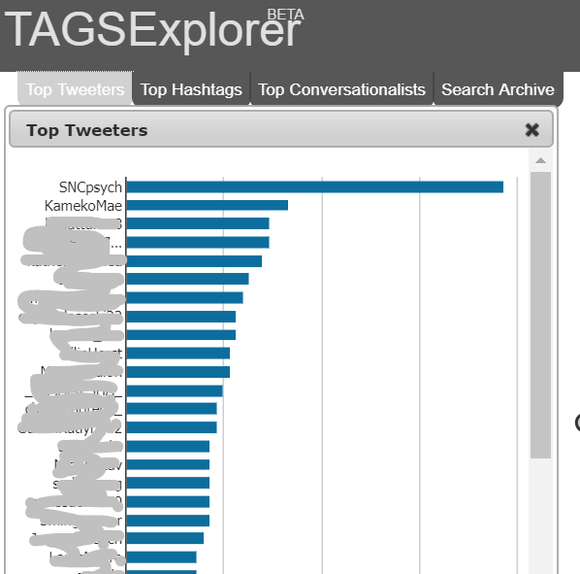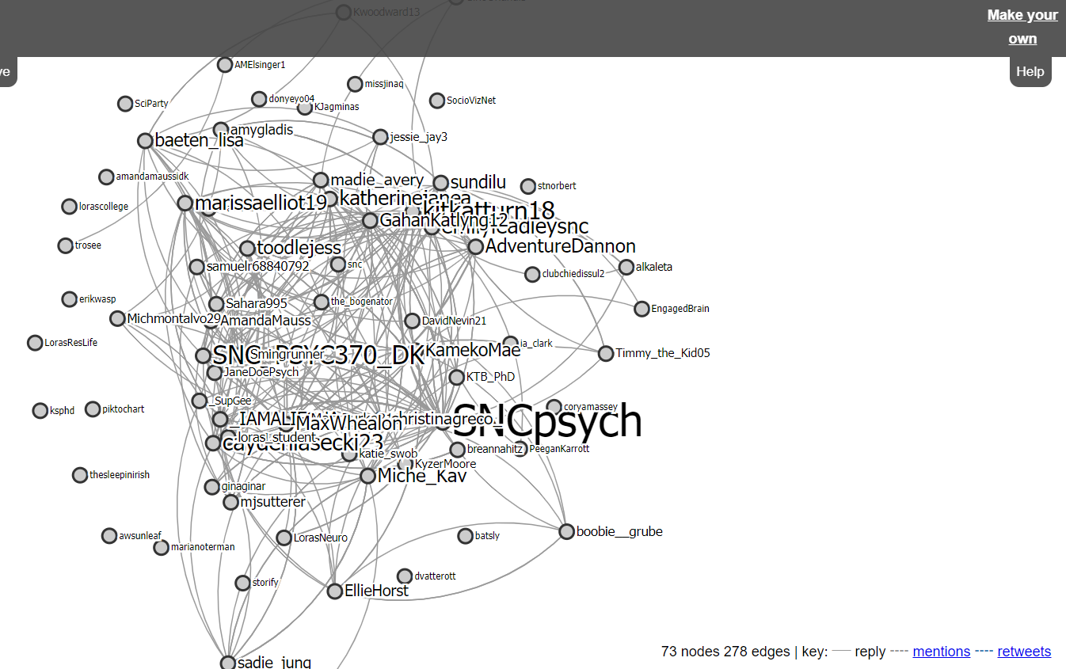
Figure 1. Example of output generated from a TAGSExplorer, including tracking top tweeters, hashtags, conversationalists, and a visualization of the conversation network.
Microblogging on Twitter would work well in a face-to-face, hybrid, or online course. For example, the Twitter hashtag could be used as a way to cultivate community in an online course, where students may not otherwise interact as much.
This assignment can be supplemented by live chats on Twitter (see Assignment 1b). For example, the instructor can facilitate a live discussion via Twitter (or another chat-enabled platform) by posing questions over the course of the discussion period. This forum for discussion allows for more interaction than a typical face-to-face discussion where only one voice can be heard at any given time.
Finally, microblogging on Twitter works best if it is required and/or incentivized in a low-stakes manner. When offered as “optional” students tend not to engage in these types of activities. If the stakes are too high, this type of social media assignment may ostracize or exclude students who prefer not to use social media at all.
The instructions to students are provided in Appendix B. The instructions to students also include a screenshot of Tweetdeck, which is a free dashboard application for managing Twitter accounts. Prior to implementing this assignment, we recommend a brief paraphrasing activity (Appendix C).

Assignment 1b: Twitter Discussion
APA Learning goals
After engaging in this activity, students will be able to
- “Describe the characteristics and relative value of different information sources” (2.2B)
- “Craft clear and concise written communications to address specific audiences (e.g., lay, peer, professional)” (4.1B)
- “Use psychological concepts to facilitate effective interactions with people of diverse backgrounds on a digital platform” (4.3B)
- “Use social media responsibly” (4.3E)
Directions to the instructor
Class discussions are a powerful learning technique that can help students can allow students to build on their existing knowledge as they continue to develop. Discussions and peer-to-peer dialog also allow students to work on putting their knowledge into action live and in the moment. Public dialog can also help students with their communication and reasoning skills. However, some issues with class discussions is that there may be inequity in the participation of students where some students may be marginalized during discussion or some students may be less willing to participate. Further, in the one-to-many, one at a time discussion model, many students may be engaged in non-task related activities. A synchronous, online discussion can address some of these issues. When students are able to respond through written form, many students can “speak” at the same time, reducing the number of students waiting their “turn.” With more specified roles in the discussion, the number of students engaged in on-task behavior can also increase. On-line discussions still allow students to work on dialog and reasoning as they respond to each other. Lastly, on-line discussions also allow for students who are uncomfortable speaking in front of large groups to contribute to the discussion.
Tracking participation in Twitter discussions can be nearly impossible as a one-hour discussion can easily create hundreds of tweets (e.g., 30 students tweeting once every six minutes means 300 tweets). Tracking is manageable with free visualization tools like Tags Explorer and socioviz mentioned above. Another tool is Node XL (http://nodexl.codeplex.com/) which costs $29 per year. By following the instructions on this medium blog post (https://medium.com/@sabrmattrics/mapping-twitter-with-nodexl-and-gephi-2d5300fdbc3b), you can scrape Twitter for the hashtag from your discussion and count tweets from student with much greater ease and graph them with greater flexibility using Gephi (https://gephi.org/). You can also include advanced metrics that can identify the student or students who were most central to the discussion.
Preparing the discussion will take some work in organization before the class and at the beginning of the class/discussion period. For a 50-60 (80) minute class, instructors should use the first five (10) minutes to organize the discussion and the last 5-10 (10-15) minutes for structured reflection. Instructors should take care to orient students to Twitter and Tweetdeck and make sure to outline the types of questions, answers, and media that qualify as high-quality posts.
Instructions to students are provided in Appendix D.

Assignment 2: Electronic Portfolio
APA learning goals
After completing this assignment, students will be able to
- “Describe the characteristics and relative value of different information sources (e.g., primary vs. secondary, peer reviewed vs. non reviewed, empirical vs. nonempirical)” (2.2B)
- “Craft clear and concise written communications to address specific audiences (e.g., lay, peer, professional)” (4.1B)
- “Use social media responsibly” (4.3E)
Directions to the instructor
Electronic Portfolios (E-portfolios) are indicated as a high impact practice by the Association of American Colleges & Universities (AACU). Portfolios require students to manage time effectively, organize information, and reflect on learning. Portfolios are “renewable” assignments meaning that their usefulness can extend beyond the course (Wiley, 2016). For example, the Hart Research Associates 2014 survey indicates that employers view E-Portfolios of students work as very useful (38%) or fairly useful (44%). This is notable in relation to employer’s indication of college transcript usefulness in job applications, where only 9% of employers find transcripts very useful and 36% find transcripts fairly useful. We recommend specifically discussing the potential for future use of the E-portfolio in job or graduate application materials with students.
This assignment would work well for smaller class sizes (<30 students) and is most suitable for upper level courses, such as a seminar or capstone course. We do not recommend this assignment for larger class sizes because of grading time constraints for a major semester project. E-portfolios are appropriate for courses that meet face-to-face and for hybrid and online courses.
Students may find setting up their website challenging. Although we have used Wordpress in our own courses, we recommend instructors use whichever platform is most comfortable for them. Wordpress offers the option for students to keep their website private/unlisted so that they privacy is not a concern. We suggest instructors spend at least one 45-60 minute class period workshopping the set-up, design, and website plan. In the past, we have invited instructional technologists to our classroom to help students get started with their website. If you decide to use this assignment as part of your course, instructional technologists, librarians, and/or media and technology support services are great resources.
Students will respond differently to flexibility in an assignment such as a portfolio. Some students will embrace the flexibility and generate creative, thought-provoking content with little need for guidance. Other students will seek out guidelines to follow and be uncomfortable with the ambiguity of this assignment. We suggest discussing these varying reactions with students from the start. Dealing with ambiguity is an important skill in many careers. For example, students will need to develop skills to problem solve, think critically, think creatively, take calculated risks, and ask questions. Working with fewer constraints will push students to develop these important skills. For example, Hart Research Associates 2014 survey for the AACU indicates that creative and innovative thinking are important skills for graduate, and employers tend to give graduates low scores on how prepared they are to think creatively. Discuss with students how this assignment will help prepare them for the job market.
To help minimize undue student anxiety about the ambiguity of this assignment, we recommend assigning two minor artifacts before the first major artifact is due and providing timely feedback on each of the minor artifacts. Then, students will have a better sense of your assessment style for this assignment. We also encourage instructors require students to meet one-on-one after the first two minor artifacts are submitted to discuss feedback in person and discuss students’ plans for the remainder of the portfolio. Instructors should also consider giving students the opportunity to revise one or two artifacts based on feedback as a separate assignment or to earn back partial credit.
Assessment of portfolios is challenging because each student’s product is different. However, this range of products offers an opportunity and student ownership of assessment. We recommend students collaborate to develop assessment criteria (although a sample rubric is provided in Appendix E with the student assignment instructions). The following questions can be used generate thoughtful discussion to create an assessment tool:
- Who is your audience? Is the method of delivery appropriate for the audience?
- In your opinion, what is the purpose of each artifact?
- What characterizes a quality artifact? What should we look for to know whether an artifact is delivering value to the audience?
- What is appropriate coverage of a concept? How should the coverage of a concept (or concepts) be assessed?
- How should creativity, professionalism, and technical skills be weighted?
- How should empirical and scholarly work be referenced? What types of resources should be considered most valuable?
Finally, we recommend the following deadlines (assuming a 15-week semester):
Week 1: Portfolio topic choice/theme due
Week 2: General portfolio plan due (provide a two to three explanation of each artifact you plan to include, knowing that these plans may change later in the semester)
Week 3: Minor artifact one due
Week 5: Minor artifact two due
Week 6: Meet with instructor to discuss feedback and revisit portfolio plan
Week 8: Major artifact one due
Week 11: Minor artifact three due
Week 14: Major artifact two due
Week 15/Finals: Revisions; Reflection on portfolio due

Assignment 3: Reddit
APA learning goals
- Describe the characteristics and relative value of different information sources (e.g., primary vs. secondary, peer reviewed vs. non reviewed, empirical vs. nonempirical) (2.2B)
- Develop a comprehensive strategy for locating and using relevant scholarship to address psychological questions (2.2C)
- Craft clear and concise written communications to address specific audiences (e.g., lay, peer, professional) (4.1B)
- Use psychological concepts to facilitate effective interactions with people of diverse backgrounds on a digital platform (4.3B)
- Use social media responsibly (4.3E)
Directions to the instructor
Reddit is an online social media site that allows users to post, comment, and interact with other users within specific communities. It is a place that you can share and learn from others across almost any interest from psychology to politics, to specific cities (e.g., Philadelphia), to almost anything else you can imagine. Here is a beginner’s guide (http://mashable.com/2012/06/06/Reddit-for-beginners/) to better understand the site (you can also use this guide: https://www.technorms.com/38809/beginners-guide-to-reddit or this one: https://www.digitaltrends.com/social-media/reddit-101/). Although many learning management systems may provide discussion forum tools, there are a number of reasons to choose Reddit. Web 2.0 tools allow users to interact and collaborate through social network tools. As a social news site, Reddit, allows quality content (content that is deemed to be most relevant or helpful) to rise to the top, so instead of seeing all content, the most upvoted content (e.g., student responses or student questions) can be the focus of discussion. Reddit also allows for the maintenance of content over time. Rather than restarting every semester with a wiped slate from your learning management system, you can continue to update and use the same Reddit threads that allow the dissemination of knowledge across time.
Setting up and moderating a subreddit (the name of an individual community on Reddit) takes time. It is helpful to install the chrome extension Reddit Enhancement Suite (RES) that helps to automate certain markdown formatting tasks like inserting hyperlinks. Before the semester begins, create a subreddit, by navigating to Reddit.com, creating an account and clicking on the tab in the upper right-hand corner. Fill out the information on the next page and select either restricted or private for your type of subreddit. This helps maintain the privacy of your subreddit for you and your students.
Once the semester starts, students will need to create accounts. Make sure to add all students to your subreddit under approved posters in the moderator section of your subreddit. The students should then try posting to the subreddit. If a student receives a warning that they are “doing that too much” when they try posting, it likely means that they haven’t been added to the class subreddit. Once they are an approved submitter to the subreddit, they can log out, log back in and then should be able to post. Students can post links to other webpages, videos or pictures that are helpful for the course content and can also reply to posts with questions. The instructions to students are provided in Appendix F.
Usage Examples
Discussion Board
Reddit is a useful mechanism for a discussion board. The instructor can post a topic with a title such as, “Discussion question for Abnormal Psychology” followed by a specific question. Students can then post replies to the question, and, importantly, they can then up-vote and down-vote other questions. This allows quality questions to rise to the top and those questions can be the focus of the instructor’s response either on Reddit or in class. Reddit allows you to post, comment, and share information both inside and outside of class. For example in Figure 2 in a physiological psychology class on executive functions, students were asked to discuss teaching techniques to help elementary, middle or high school work on executive function sub-domains. Instead of just discussing information in class or responding on white boards in the class, information was kept for beyond the class period by logging responses on Reddit. In Figure 2, you can see that 18 small groups responded to the question and we could put the responses in communication with one another on the same page to see how different individuals or groups responded to the question.
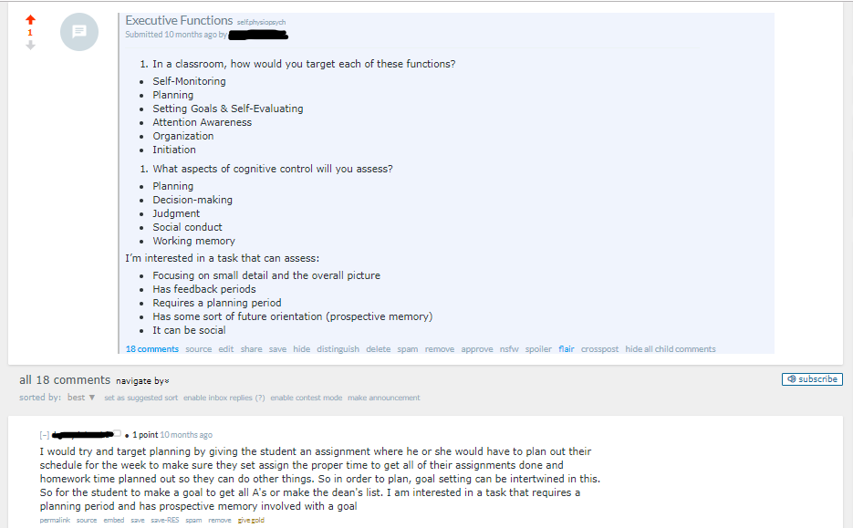
Figure 2. Reddit usage example discussion board. A question was posed to students about executive functions in a physiological psychology course. Students responded before class and allowed the class to discuss the answers in class.
Group Challenge
Reddit can also be used in class to gather group or individual responses to reflection questions or challenge questions (Figure 3). Often times in class, group work and questions are only discussed or written on boards, only to be erased. With Reddit, the responses can be gathered and again up-voted or down-voted to reveal the best responses. Another positive aspect of Reddit for in-class challenges or group work is the ability to link to the primary literature. Although many learning management systems (LMS) have discussion or chat abilities, Reddit has the benefit of being able to be accessed after the semester ends or the student graduates.
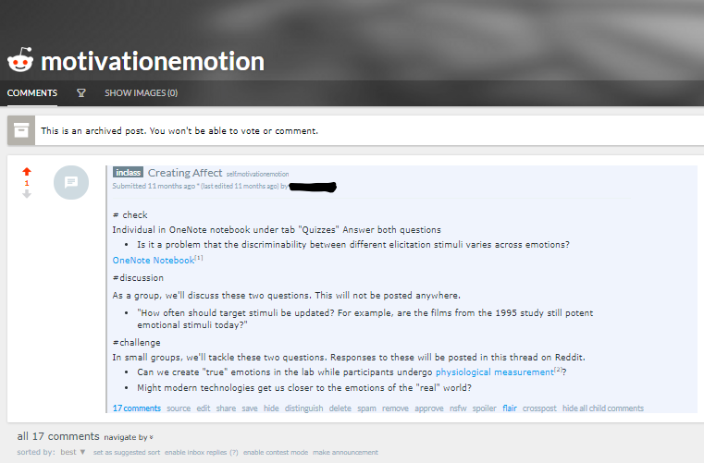
Figure 3. Reddit usage example group challenge. Students answer questions as individuals and in groups responding to the subreddit to discuss the best answers as a class.
News Update
Reddit can be used to post articles, new stories, videos and pictures and allow for comments (Figure 4). A news update allows student to find and summarize either a current event or research finding and discuss how it relates to psychology. By posting the article, story, video or picture to Reddit, all students in the class can see the item and engage with it. The student who posts the news update can provide an initial summary about the item and analyze its significance or connection to the course content. News updates allow students to bring their passions into the course content by finding creative ways to connect what they are interested in to psychological principles.
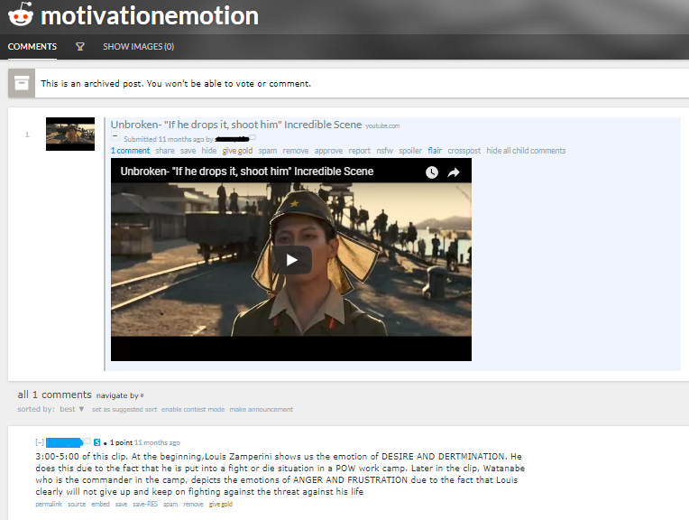
Figure 4. Reddit usage example news update. A student uploaded a clip from a video and then provides a summary of the lessons from the content that they shared.

Assignment 4: Hypothes.is
APA learning goals
- Describe the characteristics and relative value of different information sources (e.g., primary vs. secondary, peer reviewed vs. non reviewed, empirical vs. nonempirical) (2.2B)
- Develop a comprehensive strategy for locating and using relevant scholarship to address psychological questions (2.2C)
- Craft clear and concise written communications to address specific audiences (e.g., lay, peer, professional) (4.1B)
- Use psychological concepts to facilitate effective interactions with people of diverse backgrounds on a digital platform (4.3B)
Recommendations to the instructor
To be successful in college, students must be able to read and comprehend the primary literature. The traditional use of textbooks in the classroom, may become less relevant as instructors are able to design, implement and disseminate more nimble and up-to-date modular style content guided by the primary literature. However, students may find the primary literature more difficult to comprehend compared to textbooks because the level of writing is more difficult and the guidance of the writing less structured for novice scientists (Nevid & Lampmann, 2003; Varnhagen & Digdon, 2002). One way to help scaffold the learning experience is to have students submit questions on the readings and then discuss those questions in class. Allowing students to ask and then answer each other’s questions helps both the students struggling with the material (asking questions) and excelling with the material (answering questions).
Hypothes.is works well in seminars or other courses in which research papers from the primary literature form the bulk of reading assignments. Within your learning management system (LMS), you can post PDFs of articles or links to the on-line articles (like blog posts or other forms of digital media) for your class (for Hypothes.is getting started guides, see https://web.hypothes.is/education/) or you can look to use strictly open-access journal articles and link to the DOI of those articles. In addition, the Center for Open Science has recently collaborated with hypothes.is to facilitate peer feedback on preprints (https://web.hypothes.is/blog/cos-launch/). The journal articles have to “live” in one place on-line, either where open access articles host their PDF or where your library subscription database accesses journal article PDFs.
Within hypothes.is you can create private groups, post the shareable link in your LMS, and have students join the group (see Figure 5 for an example group). You can create a group by navigating to the hypothesis website, signing in, clicking on groups and create a new group. Your group will have a link that you can share with your students so that annotations are limited to your class. Students will have to be reminded that when they are on a page that they want to annotate that they must log-in to Hypothes.is and click on the group that they want to post to (postings can either be made public - readable by anyone with access to the link or restricted to the group). You can track student posting by going to Hypothes.is, logging in to your account and clicking on your course group. On the right hand side, you will see the members of the group and can click on each member to see the number of posts.
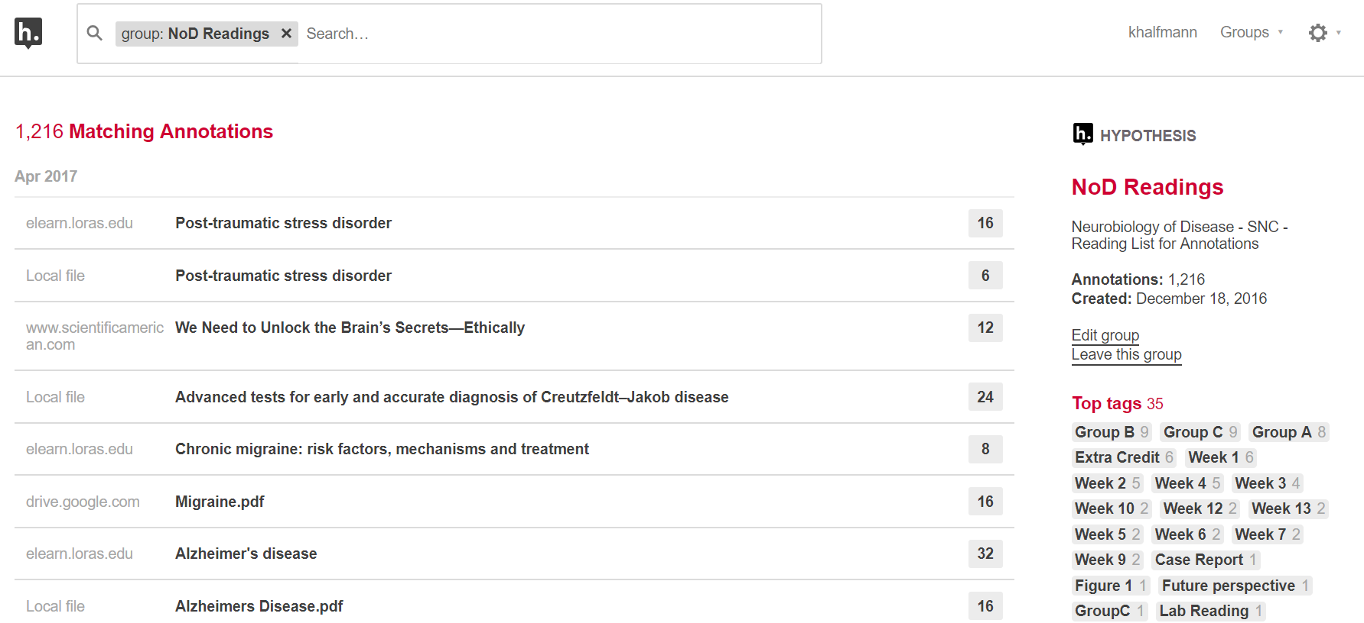
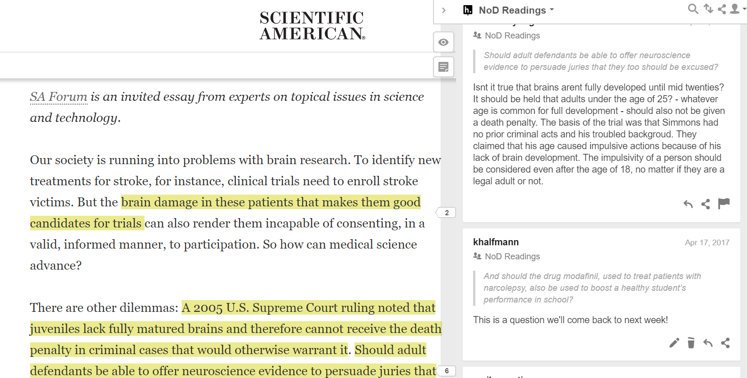
Figure 5. Top figure shows a list of readings with the group statistics and tags on the right. The bottom image shows an example of an annotated article on Scientific American with highlighted text and comments.
During class, we recommend instructors model annotating via Hypothes.is on the projector or laptops that students bring to class and see the questions, answers, and annotations in context. In addition, students can use Hypothes.is to keep notes from the class discussion on the page notes section of the Hypothes.is annotation. Hypothes.is describes 10 ways that students can use annotations (https://web.hypothes.is/blog/back-to-school-with-annotation-10-ways-to-annotate-with-students/) with teacher annotations, annotations as questions and annotations as close reading the most relevant to college students. Instructors can demonstrate the navigation of hypothesis by pre-annotating a paper with questions and answers and providing one live annotation in class. The instructions to students are provided in Appendix G.
Instructor Annotations
For particularly difficult texts, instructors can pre-populate a text with notes and explain the most difficult and important points of the reading. With social reading, you are able to facilitate reading comprehension by noting and responding to the most difficult concepts. By providing annotations ahead of time, you can also ask questions of students on the parts of the text that you want to make sure that students engage with. In Figure 6, the instructor provided students with an online article that discusses the Implicit Association Test and provides both information about difficult concepts and asks questions to help structure student learning.
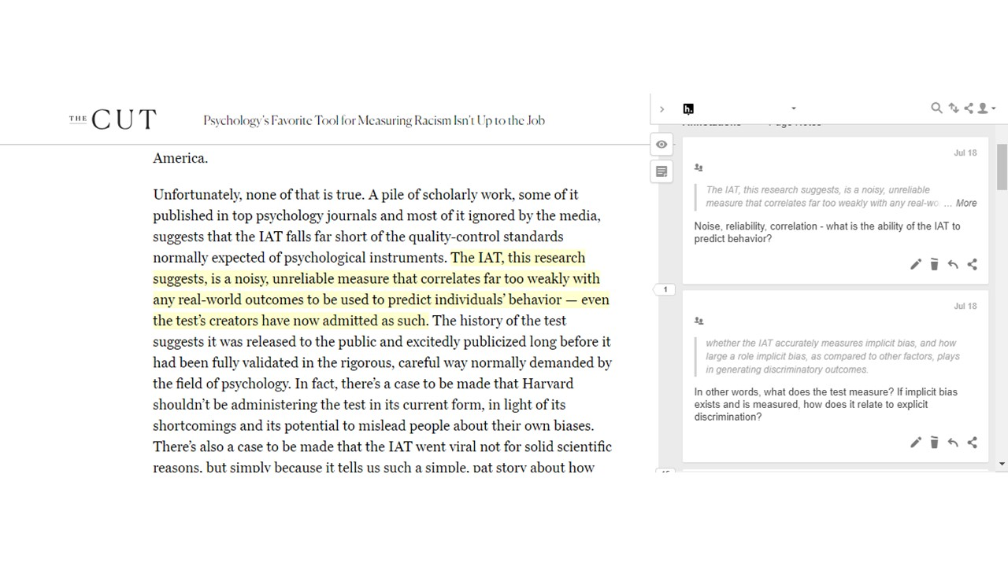
Figure 6. Hypothes.is usage example of instructor annotations. The instructor provides explanations of various difficult concepts in the assigned reading.
Annotations as Questions
Social and collaborative reading democratizes the learning process. Instead of waiting until class to understand where students excelled and where students struggled, the collaborative reading process allows students to co-construct their understanding in real time. Annotations can serve to highlight areas of the text for in-depth analysis, or bring to light the most difficult to understand part of a paper. Collaborative annotation where some students ask questions and others respond, highlights the benefits of a software like hypothes.is where students can be empowered to produce knowledge in their own right. Most helpful for a software like hypothes.is is that that knowledge lives in context in the text. Students are not required to flip from their notes to the page or from a discussion forum in the LMS to the paper, everything can be in the same place. An example of a question with answer in hypothes.is can be seen in Figure 7. One student asked for a definition of relational memory while two other students provided answers.
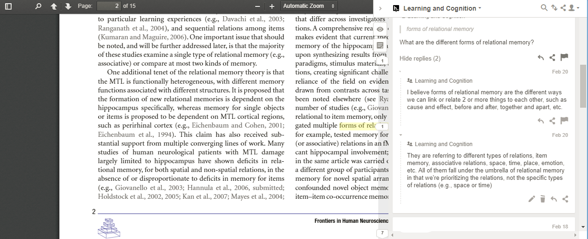
Figure 7. Hypothes.is usage example of question and answer response. One student asked a question and received two responses from their classmates.
Summary
At the beginning of the semester, we suggested the visitor/resident mapping activity to help frame the effective use of digital and social media for a professional/academic purposes. As students produce their own visitor/resident maps, it is important to keep in mind that it may be difficult for students to “re-map” their social media usage. Many student users with previous experience using the social media platforms discussed above (e.g., Twitter, Reddit) likely placed themselves as personal-visitors, that is they used the sites for personal uses and to consume content. By asking the students to flip their social media use (for the class) in two ways, turning personal to professional and visitor to resident takes time and effort. Much of the internet runs colloquially by the 1% rule, or the 90-9-1 rule of thumb (Hargittai & Walejko, 2008). This principle suggests that in online communities like wikis, Youtube, Reddit, or other forums that require content creation that only 1% of the community creates while the rest “lurk,” in other words, consume without engaging.
With this in mind, managing social media assignments requires attention and reminders about the purposes of using social media for learning. This helps students reframe their use and purpose on and within social media so they begin to see it as a way to learn even when they step outside of the classroom. The value of regularly entering the digital realm to find and communicate information will help students hone their scientific literacy skills in new and transferrable ways. With that being said, more research needs to be done to examine the effectiveness of using digital and social media assignments in higher education.

References
Association of American Colleges & Universities. (2012). A Crucible Moment: College Learning & Democracy’s Future. Retrieved from https://www2.ed.gov/rschstat/research/pubs/college-learning-democracys-future/crucible-moment.pdf.
Barczyk, & Duncan, D. G. (2013). Facebook in higher education courses: An analysis of students’ attitudes, community of practice, and classroom community. International Business and Management, 6, 1-11.
Bik, H. M., & Goldstein, M. C. (2013). An introduction to social media for scientists. PLOS Biology, 11, e1001535. doi: https://doi.org/10.1371/journal.pbio.1001535
Cavanagh, S. R. (2016). The Spark of Learning. West Virginia University Press.
Brinko, K. T. (1993). The practice of giving good feedback to improve teaching: What is effective? The Journal of Higher Education, 64, 574-593. https://www.jstor.org/stable/2959994
Brooks, D. C. (2016). ECAR Study of Undergraduate Students and Information Technology, 2016. Research report. Louisville, CO: ECAR. Retrieved from https://er.educause.edu/~/media/files/library/2016/10/ers1605.pdf?la=en
Greenhow, C., & Gleason, B. (2014). Social scholarship: Reconsidering scholarly practices in the age of social media. British Journal of Educational Technology, 45, 392-402. doi: 10.1111/bjet.12150
Hargittai, E., & Walejko, G. (2008). The participation divide: Content creation and sharing in the digital age. Information, Communication & Society, 2, 239-256.
Hart Research Associates. (2015, January). Falling Short? College learning and career success. Washington, DC: Association of American Colleges and Universities.
Ishak, S., & Salter, N. P. (2017). Undergraduate psychological writing: A best practices guide and national survey. Teaching of Psychology, 44, 5-17.
Knight, C. G., & Kaye, L. K. (2014). ‘To tweet or not to tweet?’ A comparison of academics and students usage of Twitter in academic contexts. Innovations in Education and Teaching International, 53, 145-155. doi: https://doi.org/10.1080/14703297.2014.928229
Krause, M. A. (2011, January 31). A civic scientific literacy perspective in the psychology classroom. APS Observer. Retrieved from https://www.psychologicalscience.org/observer/a-civic-scientific-literacy-perspective-in-the-psychology-classroom
Moran, M., Seaman, J., & Tinti-Kane, H. (2011). Teaching, learning, and sharing: How today’s higher education faculty use social media. Pearson Learning Solutions: Boston, MA. Retrieved from https://files.eric.ed.gov/fulltext/ED535130.pdf
Muzur, A., & Rinčić., I. (2013). Neurocriticism: a contribution to the study of the etiology, phenomenology, and ethics of the use and abuse of the prefix neuro-. JAHR – European Journal of Bioethics, 4(7), 545-555.
Nevid, J. S., Pastva, A., & McClelland, N. (2012). Writing-to-learn assignments in introductory psychology: Is there a learning benefit? Teaching of Psychology, 39, 272-275. https://doi.org/10.1177/0098628312456622
Newman, F., & Scurry, J. E. (2015). Higher education and the digital rapids. International Higher Education, 26, 13-14.
Prensky, M. (2001). Digital natives, digital immigrants. On the Horizon, 9, 1-6. doi: https://doi.org/10.1108/10748120110424816
Venkatesh, V., Croteau, A-M., & Rabah, J. (2014). Perceptions of effectiveness of instructional uses of technology in higher education in an era of web 2.0. Paper presented at the 47th Hawaii International Conference on System Science. doi: 10.1109/HICSS.2014.22
White, D. S., & LeCornu, A. (2011). Visitors and residents: A new typology for online engagement. First Monday, 16. doi: http://dx.doi.org/10.5210/fm.v16i9.3171.
Wiley, D. (2016, July 7). Toward renewable assignments [Blog post]. Retrieved from https://opencontent.org/blog/archives/4691

Appendix A
Student Activity: Visitor and Resident Mapping
Goal
Create a personal visitor-resident map and reflect on communication tools and skills
Materials
Writing utensil
Paper (or whiteboard)
Suggested Time
30 minutes
Instructions to the students
- Draw a horizontal line across your paper and label the left side “visitor” and the right side “resident” (Figure 1)
  - Think of visiting as logging onto and off of social media without leaving much of a trace (no posts, no likes, no interaction)
  - Think of being as resident as leaving a trace on social media through a post or some other form of creation or interaction
- Draw a vertical line through the center of your paper (splitting your paper into four equal quadrants) and label the top “personal” and the bottom “professional”
  - Personal encompasses your personal social media use
  - Professional is any social media use related to your career, academics, or professional interests/development
- Think of the eight to 15 social and digital media apps you use the most, such as Facebook, Snapchat, or Youtube. Place each form of social media you use into each quadrant according to your use of that form of media.
Figure 1. Sample visitor-resident map.
Once you have completed your visitor-resident map, share and discuss your map with a group of three. Address the following questions:
- Usage: What are the primary reasons you use social and/or digital media? Which of your quadrants has the greatest number of apps in it? Why do you think this quadrant is the most populated for you?
- Privacy: What are the advantages and disadvantages to sharing different content on the Internet publicly? What are strategies to protect your privacy online
- Audience: How does audience influence what you post on social or digital media? How is sharing something on social media (i.e., on Facebook) different from sharing it in person (i.e., talking to a friend)?
  - How does the issue of audience play a role when you are creating an assignment for a class or for research?
- Identity: What would your visitor-resident map have looked five years ago? How has it changed since then? How does your digital identity differ from your face-to-face identity? How does personality (e.g., openness to new experiences, conscientiousness, extraversion, agreeableness, and/or neuroticism) play a role in digital identity?
- Professional development: How do you think a potential employer might view you if the only information they had about you was what they could find by Googling you? How do you feel about this? Are there changes you’d like to make to your digital presence?
- Information literacy related to psychology: Do you use social/digital media to get news or information related to psychology?
  - How do you decide whether the source you’re using is reliable?
  - What kinds of media are acceptable evidence? Why?
- Learning: How can social media be used to create a personal learning network (i.e., an individualized set of resources that promotes learning)?
  - What forms of social media do you use to learn about psychological science, if any?
  - What forms of social or digital media could you potentially envision using to learn about psychological science?
  - How do you or could you use social or digital media to collaborate for group projects or assignments?

Appendix B
Assignment 1a: Microblogging on Twitter
Twitter is a microblogging platform that limits you to 280 characters per message, or tweet. This network allows for both synchronous and asynchronous discussion. Twitter takes us outside of the course and physical university boundaries and allows us to engage globally. Others who see our posts can join us and participate as they wish.
Consider your digital identity. How do you represent your identity on social media? For this semester long assignment, you should either create an experimental Twitter account for this course (using your real name or a pseudonym) or use your own existing account. Please share your Twitter handle with me so that I know which account is linked to you. Follow the #ExampleCourseHashtag and the account @ExampleCourseAccount. Use an application like “Tweetdeck” (see Figure 1) to help keep track of the course hashtags and other course accounts.
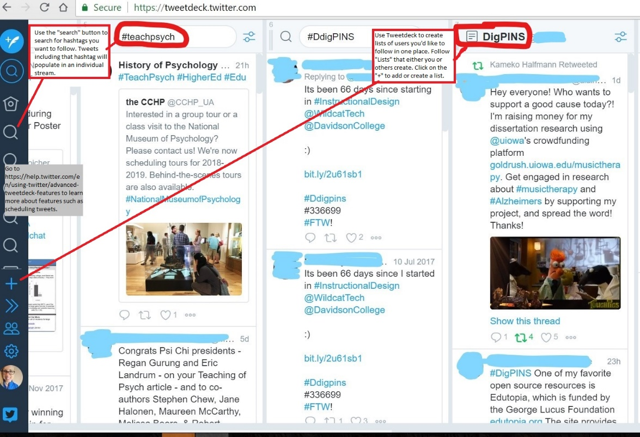
Figure 1. Example of TweetDeck set up. Advanced TweetDeck features help can be found at the following url: https://help.twitter.com/en/using-twitter/advanced-tweetdeck-features
Materials/Tools Needed
- Computer or personal computing device
- Twitter Account
Assignment Requirements
- Tweet or retweet course related material with the #ExampleCourseHashtag once per week
  - Here are some prompts or ideas for tweets:
    - Tweet something you learned from class
    - Ask a clarifying question
    - Ask a thought-provoking question
    - Share a link to a course-related article or news story
    - “This wk in @ExampleCourse XXXXX #ExampleHashtag”
  - You must use the #ExampleCourseHashtag (This is how I will keep track of your tweets)
- You may retweet up to 3 times over the semester. However, you still need to use the hashtag. The remainder of your tweets should be unique tweets.
Due
You should contribute one tweet weekly throughout the semester (tweet once per week).
Assessment
Completion (I will check Twitter each week, tally your tweets/retweets, and reply to questions and occasionally respond to other comments). At the end of the semester, students will complete a reflection and answer the following questions:
- What skills did you develop by communicating via Twitter?
- What types of information did you encounter on Twitter? How did you decide whether it was credible?
- What are the relative advantages and disadvantages of using social media for news and information compared to using a database or scholarly article?
- What are some of the challenges or concerns associated with using social media (i.e., related to privacy)?
- What was something you learned by engaging in social media for academic purposes that you would not have otherwise learned (e.g., a skill or something you encountered on Twitter)?
Appendix C
Assignment 1b: Live Twitter Discussion
Several times throughout the semester, we will hold a synchronous Twitter live chat on course content. The purpose of this is the engage each student in discussion (more so than a face-to-face discussion allows because many conversations can occur simultaneously). We will use a course specific hashtag. You should use TweetDeck to help keep track of the hashtag. You should include the discussion hashtag in EVERY tweet.
In each Twitter Discussion, students will be assigned different roles:
- Question Master: Raise questions on the topic and reading. This will require preparation before class
- Answers Ace: Answer questions from Question Master
- Multimedia Czar: Bring in relevant, pictures, GIFs, videos, and polls
- Synthesizer: Pull together themes and commonalities across questions and discussions. Raise takeaways. If it's early and there are not themes yet, your job is to reach out to others on Twitter to join the discussion
You will rotate through the different roles across the semester.
Format
- First, I will ask everyone to introduce themselves
- Question Masters should have several questions prepared prior to the discussion. They will then be asked to pose questions in the following format every 10 minutes:
  - Q1: Describe your reaction in 280 characters #SampleHashtag
- Answers ACE, Multimedia Czar, and Synthesizers would then have the opportunity to respond to the Question Master and/or others in the conversation:
  - A1: Faces in the clouds, how weird! #SampleHashtag
Assessment
Students should contribute a minimum of ten times to the live chat. Make sure to use the hashtag to be counted. This will be assessed based on completion. All students are encouraged to take advantage of other advanced uses of Twitter by “favoriting” and re-tweeting questions or answers that they find the most useful or interesting.

Appendix D
Paraphrasing activity
Read the following paragraph, then use 1-2 sentences to re-write the paragraph.
Feng, S., D’Mello, S., & Graesser, A. C. (2013). Mind wandering while reading easy and difficult texts. Psychological Bulletin Review, 20, 586-592.*
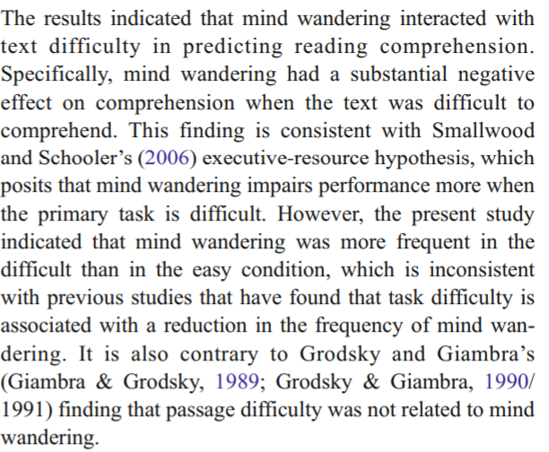
After you have paraphrased the paragraph, trade sentences with another person. Critique each other – did you adequately paraphrase the paragraph? Beware of “relexifying,” which is when you change words by using synonyms but do not change the structure of the writing.
- Discuss with your partner why paraphrasing is an important skill.
- Discuss what is most challenging about paraphrasing.
- Discuss plagiarism and appropriate contribution of credit.
- Revise your paraphrase after you receive peer feedback.

*This study is part of the Open Science Framework Collaborative Replications for Education Program.

Appendix E
Assignment 2: Portfolio
Goal: Create a website or blog that features five artifacts created by you on a particular course related topic. An artifact is a tangible product that you create. Suggestions for artifacts are outlined below.
For this semester-long project, your goal is to create two “major” artifacts and three “minor” artifacts to be included on your website/portfolio. Each artifact should teach the public about or inform the scientific community about an aspect of your topic. Major artifacts should be thought of akin to a midterm or term paper, which take approximately 20 hours to complete (including research, reading, and composition). Minor artifacts should be thought of akin to smaller milestone papers, which take about 3-6 hours to complete, each. There is considerable flexibility in how you compile your portfolio. I am expecting a professional website that I would reference for information on your topic. I recommend using Wordpress to create a free website/blog. Choose a clean, professional theme.
Each major artifact should incorporate four unique peer reviewed references that you found using a scholarly database such as PsycArticles, PsychINFO, or Google Scholar. These may be review articles, meta-analyses, or empirical research articles. Each minor artifact should reference at least one unique reference. In other words, you will ultimately find, read, and reference eleven unique peer reviewed articles for your portfolio.
Materials Needed
- Computer
- Account for free website builder (e.g., Wordpress, Wix, Weebly, Squarespace)
- Other software depending on artifacts (e.g., recording equipment, Audacity, Piktochart)
Minor artifact example: Infographic
An infographic is a visual representation of information or data. The goal of an infographic is to take a complex concept and distill the concept into a digestible, visual form. Your infographic should be
- Geared toward a target audience
- Focused with approximately five to seven pieces of information or evidence
- Cite sources including any images you use
There are a number of tools you can use to create an infographic. Try using free versions of Piktochart (piktochart.com), Canva (canva.com/creat/infographics), visme (visme.co/make-infographics), or google charts. Once you have created your infographic, you should post it onto your website as a .png, .jpeg, .pdf or using a link.
Major artifact example: 20 minute, produced podcast
A podcast is a digital audio recording. Your podcast should be approximately 20 minutes long and edited or produced to sound reasonably professional. A quality podcast will include intro/concluding music, narration (a spoken part of the podcast), an interview (with an expert or someone who has first-hand experience), and sound effects when appropriate. When you record your podcast episode, do not forget to introduce yourself, guests, and your “show.” Also, make sure to cite any sources you use in the show notes or at the closing of the podcast.
Before creating a podcast, you should listen to a few. You can use iTunes, Stitcher, or an app of your choice to search for and find podcasts. A few recommendations for inspiration are Hidden Brain, Freakonomics, StoryCollider, or Speaking of Psychology.
You can record your podcast using your phone, laptop, or by going to the University’s media and technology services department. Once you have a recording, you can use a free audio editor such as Audacity to edit your recording (i.e., cut out parts of the recording, add music). Finally, you should make your recording accessible by uploading it to SoundCloud, Podomatic (which also allows you to record), or an audio hosting site of your choice.
Additional artifact ideas
- Write a grant proposal
- Blog post critiquing psychological concept in popular media (music, film, other)
- Volunteer and write a reflection on your volunteer experience
- Write a New York Times style article
- Video animation of a psychological concept
- Create an instructional video
- Create a playlist and describe how each song relates to your concept/topic
- Microblogging on Twitter and creating a “moment” or “storifying” it
Self-evaluation and reflection
At the end of the semester, students should complete the following self-evaluation and reflection.
- Approximately how much time and effort did you put into each artifact?
- How would you rate your effort on your portfolio (poor, adequate, good, or excellent)?
- What was the most challenging part of this assignment?
- What was the most rewarding part of this assignment? What part of your portfolio are you most proud of?
- If you were to complete a similar assignment in the future, what would you do differently?
- What skills did you develop by creating a portfolio?
- How did creating a portfolio help you learn about your psychological concept/topic?
- Would you share your portfolio with a potential employer or admissions committee? Why or why not?
Assessment
Student artifacts will be assessed in the following domains, which are broad enough to be applicable to a wide variety of artifacts.
- Organization, logical flow, cohesiveness
- Technical savvy and appropriate use of the media
- Visual appeal and appropriate for audience
- Evidence based content and synthesis of material
- Appropriate resources and referencing
Major artifacts are worth a 50 points each. Minor artifacts are worth 15 points each. The following scale will be used for each domain for major and minor artifacts:
 | Novice | Intermediate | Proficient | Distinguished | Master
Major (points) | 1 | 2.5 | 5 | 7.5 | 10
Minor (points) | 1 | 1.5 | 2 | 2.5 | 3
Organization, logical flow, cohesiveness
Technical savvy and appropriateness use of media
Visual appeal and appropriateness for audience
Evidence based content and synthesis of material
Appropriate resources and referencing

Appendix F
Assignment 3: Reddit
Goal
Use Reddit to organize class period, discussion and outside of class posting.
Materials/Tools Needed
- Computer or personal computing device
- Reddit Account
- Chrome Browser
- Reddit Enhancement Suite (RES) browser extension
Discussion Board
Reddit is a useful mechanism for a discussion board. The instructor will submit a post that students will either be asked to write a response to or ask a question about. Students are asked to post replies to the question. Please make sure to post your replies two days before class. Then, students should make sure to up-vote posts that students feel to be high quality responses or questions that they want to for sure have answered. Students can also down-vote other questions or responses so that quality questions/responses to rise to the top and those questions/responses can be the focus of the instructor’s response. Your votes should be cast the day before class so that in class we can respond to the top answers/questions.
Group Challenge
In class, I will post questions or challenges for the class. Often times in class, group work and questions are only discussed or written on boards, only to be erased. With Reddit, the responses can be gathered and again up-voted or down-voted to reveal the best responses. Each class period I will post a number of questions. Two questions will be answered on your own and then the reminder of questions will be discussed in small groups and summarized by one of your group members. Finally, we will discuss all group responses at the end of class.
News Update
Reddit can be used to post articles, new stories, videos and pictures and allow for comments. I want you to find and summarize either a current event or research finding and discuss how it relates to psychology. Please find something that you’re passionate about and find a connection to psychology. After you post your article, video or other media content to our Reddit, please make sure to make a comment and provide and initial summary about the item and analyze its significance or connection to the course content.
Assessment: You will be assessed on completion. I will check Reddit each class, tally your posts/responses, and reply to questions and occasionally respond to other comments. You are asked to participate in every Reddit thread, but you are allowed to miss 10% of opportunities. For example, if there are 20 threads, you are allowed to miss two threads.

Appendix G
Assignment 4. Hypothes.is
Goal
Use Hypothes.is to promote critical reading skills and discussion inside and outside of class.
Materials/Tools Needed
- Computer or personal computing device
- Hypothes.is account (free)
- Chrome Browser
- Hypothes.is browser extension
Assignment description (for the students)
Hypothes.is is a website plug-in that brings a conversation to the web allowing us to hold discussions, read socially, and take notes on websites or web-hosted documents. This allows for notes, questions, and answers to be crowdsourced, which means that we can learn from each other. Across the semester, you will post questions on one-third of papers, answers to other students’ questions to a second third of papers, and annotate confusing parts of the paper on the final third of papers. Your questions should be thoughtful, analytic, and challenging. They should not be “Googleable” in two seconds (however, feel free to include comments with links to anything that you did need to Google). You will be assigned to one of three groups and rotate through the question, answer, and annotation roles on papers throughout the semester.
If you are answering questions or annotating confusing parts of the paper, you should post your annotations two days before our class meeting. For example, if we are discussing Memory and Morality on 10/21, your annotations and questions should be submitted by 10/19. For those of you answering questions, your answers are due the day before class. Using the previous example, your answers to your classmate’s questions would be due on 10/20.
To get started, follow this link, https://web.hypothes.is/start/ and then make sure to click on the link on our LMS to join our class group. Once you have hypothes.is installed and you are signed in, when you open a PDF in browser, you need to click on the hypothesis browser plug-in to activate hypothes.is. Once it is active, make sure to select our class group before making annotations.
Assessment
Students should contribute two posts (questions, answers, annotations) for each class meeting. This will be assessed based on completion. You are allowed to miss 10% of required posts without penalty. For example, if we have 20 required days of posts for the semester, you are allowed to miss 2 days of posts.

