Cognitive Psychology Games Day Manual

Joshua D. Fetterman¹ and Meredith Kneavel²
¹Chestnut Hill College, ²La Salle University

Corresponding author:
Joshua Fetterman, PhD
Chestnut Hill College
Philadelphia, PA
FettermanJ@chc.edu

Copyright 2024 by Joshua Fetterman and Meredith Kneavel. All rights reserved. You may reproduce multiple copies of this material for your own personal use, including use in your classes and/or sharing with individual colleagues as long as the author’s name and institution and the Society for the Teaching of Psychology (STP) heading or other identifying information appear on the copied document. No other permission is implied or granted to print, copy, reproduce, or distribute additional copies of this material. Anyone who wishes to produce copies for purposes other than those specified above must obtain the permission of the authors.

Table of Contents
Preface: Evidence of Effectiveness………………………………………………………………………...3 Chapter 1 Introduction 7
Section 1 What’s Included 7
Section 2 Suggested ways to use demonstrations 7
Section 3 Suggested Cognitive Play Day 7
Chapter 2 Understanding the Problem 9
Demonstration 1 The Mutilated Checkerboard Problem 9
Chapter 3 Problem solving strategies 13
Demonstration 1 The Tower of Hanoi 13
Demonstration 2 The Hobbits and Orcs Problem 17
Chapter 4 Functional Fixedness 21
Demonstration 1 The Lit Candle Problem 21
Demonstration 2 The Water Jug Problem 25
Chapter 5 Creativity 29
Demonstration 1 The Cheap Necklace Problem 29
Demonstration 2 The Nine Dots Problem 33

Preface: Evidence of Effectiveness

This manual is set up to present a number of specific problems that can be used either individually or as a group to illustrate problem solving in cognitive psychology. Before we present the problems themselves, we would like to share some evidence that these are effective means of increasing student learning and enjoyment of this topic.

Assessment of Activities

In order to assess whether students enjoy and learn from these activities, we asked 99 graduate and undergraduate students who were taking a cognitive psychology course either online or in person several questions after they participated in cognitive play day. Students taking the course online used the links that we have provided in this manual and students taking the course in person did the activities as described in this manual.

We began by asking students several likert-format questions. Students responded on a scale ranging from 1 (disagree strongly) to 7 (agree strongly). We ran three factorial between subjects ANOVAs crossing student status (undergraduate vs. graduate) with classroom context (online vs. in person) and with student enjoyment, student engagement, and enhancement of understanding as outcomes, respectively. The results indicated that both types of students, regardless of classroom context, responded at a very high level to all of the questions. See figures 1 through 3 below. No main effects were significant (although see figure 3 for a marginal effect). These results indicate that students of both types enjoyed and benefitted from these activities greatly, regardless of classroom context.

Figure 1
Responses to, “I enjoyed the activities from class today.”

Figure 2
Responses to, “I was engaged in the actives that I did today.”

Figure 3
Responses to, “The activities that I did today enhanced my understanding of the associated chapter.”

Note: In this analysis the main effect of classroom context was marginally significant, (F(1, 95) = 2.81, p = .097). Online students (M = 6.31, SD = .76) found the activities slightly more helpful than face-to-face students (M = 5.98, SD = 1.01). This difference, however, is small in magnitude (eta squared is .03) and still indicates that students from both contexts understood these concepts better after doing the activities.

We also asked several open-ended questions to gain a more qualitative perspective of students’ experiences completing the activities. Their responses were overwhelmingly positive. For example, in response to the question, “If you felt that the activities enhanced your understanding of the associated chapter, please elaborate on that idea. What about it helped you understand the chapter? If you felt that they did not enhance your understanding of the associated chapter, then please explain how you think they could be adapted to be more helpful, or suggest a different task that might better enhance your understanding” one student responded, “Hands on activities that involve visual stimuli really help me grasp the material.” Another student responded, “I had never done these activities before, or seen them in prior psych classes. I believe they helped elaborate on the concepts demonstrated in the lecture.” In response to the question, “Describe how the activities, including the Tower of Hanoi, The Orcs and Hobbits problem, the Candle Stick problem, the Nine Dots problem, the Cheap Necklace problem, the Mutilated Checkerboard problem, and the Three Jugs problem enhanced your understanding of problem solving. What about it helped you understand the chapter,” on student said, “They were all pretty interesting in helping to better understand the ways in which individuals tackle difficult problems. Looking at the solutions, there were a few that I tackled differently at first (probably why I did not accomplish them). They made me think about how people make decisions about the best ways to tackle a problem.” Another student responded, “I love problem-solving games, so these were right up my alley. It was cool to see that you listed the Tower of Hanoi, for it is similar to a task we often administer in assessment cases (i.e., "Tower Test"). These games forced me to engage in problem-solving strategies that we ask our clients to in assessment. They certainly made me think. I was thankful to see the strategies/solutions offered at the end. The Orcs/Hobbits problem was especially tricky, in my opinion! Taken together, these games helped me better understand problem-solving.” As with the quantitative data, we took these responses to indicate that students enjoy these activities and find them to be valuable learning experiences.

Introduction
We use problem solving when we want to reach a particular goal and there are generally several aspects of problem solving: 1) understanding the problem 2) problem-solving strategies 3) factors that influence problem solving and 4) creativity. Each of the interactive demonstrations is designed to illustrate different aspects of problem solving based on classic problems and illustrations in cognitive psychology.
For each area of problem solving, there is a definition of this aspect of problem solving and a short explanation of the background of this area of research. This is not meant to be a comprehensive review of this area.

What’s Included
Each type of problem solving then has one or two demonstrations with descriptions that include: A) the original research background and explanation B) materials needed C) instructions to give to students D) solutions. The instructions and solutions each appear on their own page for convenient printing.

Suggested ways to use demonstrations
There are several suggested ways that you can use this manual.

- Select individual demonstrations to do in class in a piecemeal fashion as you cover related topics in lecture.
- Hold a “Cognitive Play Day” where you use an entire class period to have groups of students rotate through all the activities.
- Integrate in-class and online activities. Online descriptions of each activity are provided in this manual. However, this manual also has an accompanying app that was developed by the authors (search for “Cognitive Game Day” and find the app that is a white brain on a red background) available for free download in the Apple’s App Store and Google Play that directs students to the online version of each demonstration. This app will work on tablets and smart phones.

Suggested Cognitive Play Day
Instructors can use each demonstration flexibly leaving adequate opportunity for the student to learn the associated concepts. We have used these demonstrations before the students have read about them to illustrate concepts and will outline our procedure below. We usually present them as a group of activities that students go from station to station to do though they can be presented as individual activities to highlight specific concepts. We will describe the group of activities/ station approach below.

- Set up stations for each activity with all the materials, short explanation, and instructions at stations around the room.
- Include the ‘answer’ in an envelope. Ask students not to look at the answer until they have attempted to solve the problem.
- As students enter the room and you begin class, describe the overall purpose and background of problem solving as described in the manual. Explain the purpose of each demonstration is to illustrate a different aspect of problem solving and is based on a classic experiment in cognitive psychology. They will work together in groups (usually 3-4 student in each group works best). If you have large classes, you may consider setting up multiple stations of the same demonstration and/or providing downloads of the app (Cognitive Play Day from the App Store, free) to accompany the demonstrations.
- Have students rotate through the stations at a pace of about 8-12 minutes per station. At around the 10 minute mark, have the student groups reveal the answer to problems if they have not already solved it.
- Have students rotate to a new station.
- Leave some time at the end to discuss the experiences.

Understanding the Problem

In problem-solving research, understanding the problem implies that you have represented the problem with a well-organized mental representation of the problem from both your own experience and information provided in the problem (Benjamin & Ross, 2011). Being able to accurately represent a problem increases the ability to solve a problem. But having an incorrect representation can make solving the problem very difficult.

The Mutilated Checkerboard Problem

Background

A well-known example of this phenomenon is the mutilated-checkerboard problem (Kaplan & Simon, 1990). This demonstration requires a checkerboard with two of the squares on the opposite corners of the checkerboard removed. Participants are asked to use 31 dominoes to cover all of the remaining 62 squares on the board, such that each square is covered. Participants are asked to find a way to arrange the dominoes on the board in this way, or to explain why this is not possible. The solution is that it is not possible to do this task. This is because each domino necessarily must cover one black and one white square. However, with two squares from opposing corners removed, the board does not have an equal number of white and black squares. Despite the fact that this explanation is logical and straightforward, people do not typically think of the problem in this way. Instead, they focus on the fact that there are 62 squares and 31 dominoes, so they assume it can be done somehow (i.e., they represent the problem in a way that makes it harder to solve).
Students may struggle to understand what is meant by “problem representation.” An illustration in Anderson (2020) can be used in conjunction with the mutilated checkerboard problem to help them understand this concept. The puzzle is as follows:

“In a village in Eastern Europe lived an old marriage broker. He was worried. Tomorrow was St. Valentine’s Day, the village’s traditional betrothal day, and his job was to arrange weddings for all the village’s eligible young people. There were 32 eligible young women and 32 eligible young men in the village. This morning he learned that two of the young women had run away to the big city to found a company to build phone apps. Was he going to be able to get all the young folks paired off?”

Most people find this puzzle easy to solve. The answer is that the marriage broker cannot do this. If there are an unequal number of men and women it is clearly not possible to create couples that both involve one man and one woman (it is worth mentioning to students that the problem presupposes that a marriage can only involve one man and one women). This is easy to see because of the way we represent the problem (i.e., pairing an unequal number of men and women together). Point out to students that the underlying structure of the problem is actually identical to that of the mutilated checkerboard problem, which is solved by realizing that you are being asked to pair together an unequal number of white and black squares. But what makes the mutilated checkboard problem more difficult to solve is that people don’t think about the problem as just described. In other words, they use a representation that inhibits, rather than facilitates, problem solution.

Online description: https://www.youtube.com/watch?v=bS3EqMcIlAQ&t=5s
Solution: https://www.youtube.com/watch?v=qazyqldHr9c&t=7s

Materials needed for in person version:

- Instruction sheet
- Solution sheet
- One checkerboard with two diagonally opposing corners removed. We recommend that you remove white squares, but if you prefer to remove black ones then update the problem solution below accordingly. You can purchase your own checkerboard and cut the squares off yourself or cover the squares with tape if you’d prefer to not destroy the checkerboard. Alternately, for a lower cost solution, you can print a checkerboard from an image on the internet (go to images.google.com and search for “printable checkerboard”) and cut the squares off.
- 31 dominoes. If you purchase a full sized checkerboard standard sized dominoes should fit. If you print out your own checkerboard you will have to cut 31 paper dominoes yourself sized to fit over two squares on the board. Numbering the dominoes may help you to be sure you are providing the correct number. If you are making your own dominoes make sure that the dominoes are sized so that one domino fits over two squares on the board.

Instructions

The checkerboard in front of you has two opposing corners removed. This leaves 62 squares. We have 31 dominoes each of which covers exactly 2 squares on the board. Your goal is to find a way of arranging these 31 dominoes on the board so that they cover all 62 squares. If you feel it cannot be done, then offer compelling proof that this is the case.

Solution to the Mutilated Checkerboard Problem

It is not possible. Each domino must cover exactly 1 white square and 1 black square because of how the dominoes are shaped. A checkerboard has 64 squares (32 white squares and 32 black squares). We have removed 2 white squares. Now there are 62 squares total: 32 black squares and 30 white squares. If each domino must cover exactly 1 white square and 1 black square, and you must use all 31 dominoes, and there are an uneven number of white squares and black squares, it is not possible to complete this task.

Problem solving strategies

Once you understand the problem, you try to apply a strategy to solve the problem. Some strategies can be very time consuming, whereas others lead you to the answer more quickly. In other words, effective problem solving will involve choosing an effective strategy.

The Tower of Hanoi

Background

One problem solving strategy involves the means-ends heuristic. When employing this strategy, a problem solver breaks the problem down into a number of subproblems, or smaller problems, and then tries to reduce the difference between the initial state and the goal state for each of the subproblems (Bassok & Novick, 2012). Means-ends heuristic refers to the identification of the end or final result and the means or methods by which a problem solver will reach those ends (Feltovich et al., 2006; Ward & Morris, 2005). The Tower of Hanoi demonstration is an effective and engaging method of illustrating this concept to students. The Tower of Hanoi involves moving discs across several pegs (according to a set of rules) and illustrates the importance of setting sub-goals.

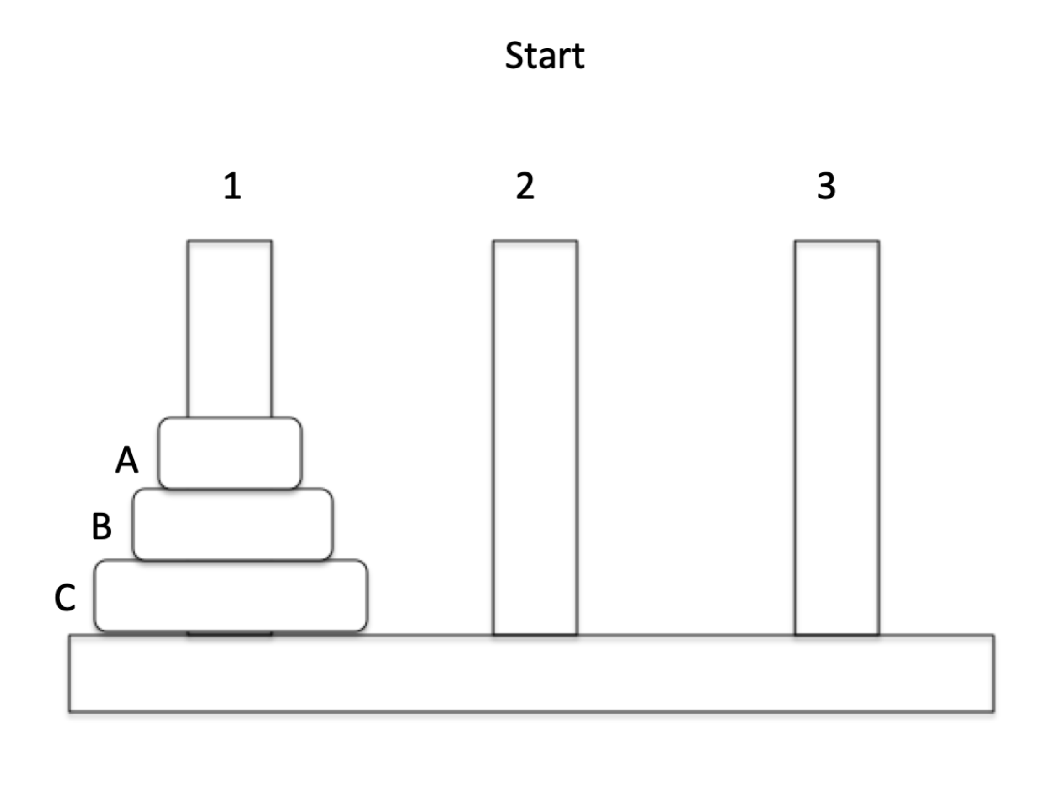

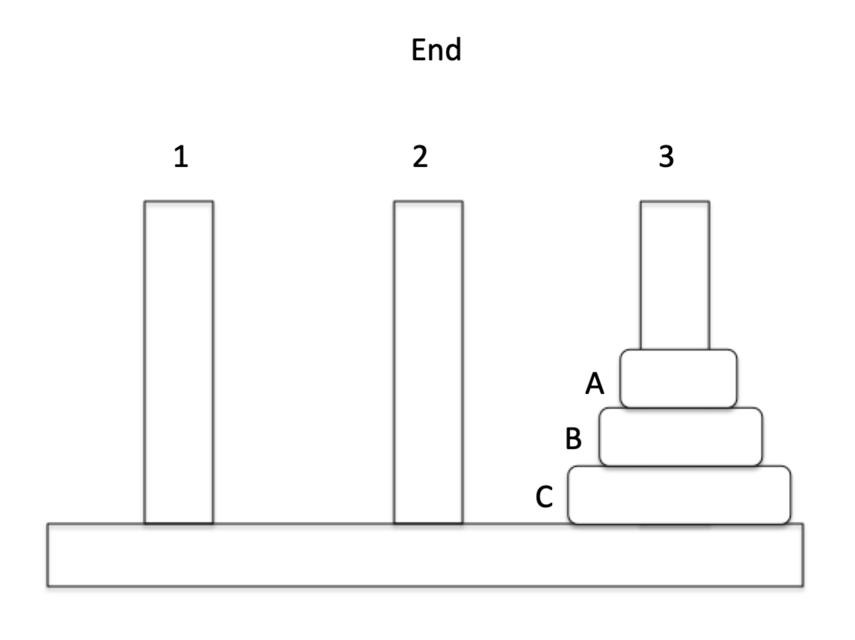

The goal of this demonstration is to move all of the discs from peg #1 to peg #3. The pegs must appear in the same order on peg #3 that they are in at the start on peg #1. Participants do this by moving the discs onto different pegs. However, participants a) can only move one disc at a time, b) must put a disc back on a peg before picking up a new one and c) can never place a larger disc upon a smaller disc. Following these three rules makes the demonstration difficult. The solution is to move Disc A to Peg 3, Disc B to Peg 2, Disc A to Peg 2 (on top of Disc B), Disc C to Peg 3, Disc A to Peg 1, Disc B to Peg 3 (on top of Disc C), and finally Disc A to Peg 3 (on top of Disc B). This is the most efficient solution (i.e., the solution with the fewest number of moves). It is important to make sure that students understand the rules about moving the discs in order for them to truly experience the activity.

Online description: https://www.mathsisfun.com/games/towerofhanoi.html
Solution: https://www.youtube.com/watch?v=GxYQCQB4CDM

Materials needed for in person version:

- Instruction sheet
- Solution sheet
- A Tower of Hanoi. This can be purchased from amazon.com for around $10 USD, although more expensive versions are available. We recommend using a 3-peg version, because this will be easiest for students to solve in a brief amount of time, but there are more complex versions with more rings and more pegs. It would also be possible to make your own Tower of Hanoi with a small board of wood, three nails (driven up through the wood) to serve as pegs, and 3 washers of different sizes to serve as the discs.

Instructions

There are three pegs and three disks of differing sizes, A, B, and C. The disks have holes in them so they can be stacked on the pegs. The disks can be moved from any peg to any other peg. Only the top disk on a peg can be moved, and it can never be placed on a smaller disk. The disks all start out on peg 1, but the goal is to move them all to peg 3, one disk at a time, by transferring disks among pegs. The goal is to do this in as few moves as possible.

Solution to the Tower of Hanoi
A = smallest ring, B = medium ring, C = largest ring

- Move A to pole 3
- Move B to pole 2
- Move A to pole 2 (on top of B)
- Move C to pole 3
- Move A to pole 1
- Move B to pole 3 (on top of C)
- Move A to pole 3 (on top of B and C)

The Hobbits and Orcs Problem

Background
A second problem solving strategy is known as the Hill-Climbing Heuristic. The Hill-Climbing Heuristic is goal setting in which you choose the goal that appears to get you closest to the final goal at each step. It can be useful when you do not have enough information about all of your alternatives. However, problem solvers may fail to choose an indirect alternative that may have greater long-term benefits. For example, imagine two hills that are next to each other, one taller and one shorter. A hiker wants to get to the top of the tallest hill to see the view, so the hiker decides to begin hiking up and not stop until she gets to the top of the tallest hill. This strategy will not work if, for some reason, the hiker ends up climbing the smaller hill; when she gets to the top of this hill it is no longer possible to go up. In order to reach her goal, the hiker must first go down, but she may be reluctant to do that because by going down she is actually getting further away from the top of the tallest hill (a concept called “backup avoidance”). A classic example of these concepts involves trying to move hobbits and orcs across a river (according to a set of rules) and illustrates back-up avoidance as well as hill climbing.

The Hobbits and Orcs Problem is somewhat famous. You may have encountered this problem under a different name, such as the “monsters and munchkins” problem. We have also found that current students are unfamiliar with The Lord of the Rings series, so it may be necessary to explain to them what hobbits and orcs are. The idea behind this problem is that three orcs and three hobbits are on one side of the river. They all need to cross to the other side of the river and they have a rowboat to carry them across. However, the rowboat can only take two creatures across the river at a time and one creature would need to pilot the boat to return it to original side of the river to pick up more creatures before it can be used again. Furthermore, at no point can the orcs on one side of the river outnumber the hobbits on that side of the river (otherwise, the orcs will eat the hobbits). The goal is to get all of the creatures across the river using the boat according to these rules.

The confusing part of this problem is that the goal is to get all of the creatures to the other side of the river, so problem solvers are tempted to blindly take them across the river according to the rules (i.e., hill climbing). Because the goal is to get all of the creatures across the river, problem solvers are reluctant to return creatures to the original side of the river once they have crossed (i.e., backup avoidance). However, as can be seen in step seven of the solution below, this is exactly what is necessary in order to solve the problem. The difficulty arises because this seems at odds with the overall goal of the problem (i.e., get all creatures across the river).

We have found that students enjoy this problem but sometimes struggle with several aspects of it. First of all, it is important to make sure that students pay attention to the rules (e.g., orcs can never outnumber hobbits, the boat cannot return across the river without a creature piloting it). Otherwise, they may think they have solved the problem when they have not. Also, while it is possible to have students do this one without any materials, they find it difficult to keep track of the placement of all creatures when relying entirely on mental visualization. To help with this problem, give them some sort of physical entities to keep track of where the creatures and boat are, such as three orc and three hobbit figurines and a boat.

Materials needed for in person version:

- Instruction sheet
- Solution sheet
- Optional: three orc figurines, three hobbit figurines, and a boat. If actual orc and hobbit figurines are unavailable any physical objects that can be designated as the creatures. In fact, it might be fun to have students actually play the roles themselves (this would require groups to have at least six members)

Online description: https://www.transum.org/software/River_Crossing/Level3.asp
Solution: https://www.youtube.com/watch?v=ZOY5h-UNBnk&t=1s

Instructions

On one side of the river are three hobbits and three orcs. They have a boat on their side of that is capable of carrying two creatures at a time across the river. The goal is to transport all six creatures across to the other side of the river. At no point on either side of the river can orcs outnumber hobbits (or the orcs would eat the outnumbered hobbits). The problem, then, is to find a method of transporting all six creatures across the river without the hobbits ever being outnumbered.

Solution to the Hobbits and Orcs Problem

State 1: boat, 3 hobbits, 3 orcs
State 2: boat, 1 hobbit, 1 orc cross to the other side of the river
State 3: one hobbit has taken the boat back across
State 4: two orcs take the boat to the opposite side of the river (so now there are 3 hobbits on the original side and 3 orcs across the river)
State 5: one orc returns the boat to the original side
State 6: two hobbits take the boat to the new side
State 7: One hobbit and one orc take the boat and return to the original side
State 8: Two hobbits take the boat to the new side
State 9: One orc takes the boat to the original side
State 10: Two orcs take the boat to the new side
State 11: One orc takes the boat to the original side
State 12: Two orcs take the boat to the new side.

The difficulty with solving this problem is something called ‘hill climbing’ or ‘difference reduction.’ It is our resistance to going backwards to solve a problem. At step 7, it looks like and feels like we are getting closer to the start state of the problem rather than closer to the solution as there are more hobbits and orcs on the original side of the river than on the new side of the river. In a study by Jeffries et al. (1977), about 1/3 of all participants chose to back up to a previous state 5 rather than moving on to state 7.

Functional Fixedness

Functional fixedness is a factor that influences problem solving by causing us to rely too heavily on an object’s intended use. For instance, only seeing a stapler as something that can join pieces of paper together and not a paperweight. One area that allows us to function in our world is through top-down processing. This is when our concepts, experiences, and memories influence our perceptions and help us make quick decisions about things in our world. This fast and quick decision-making can often be beneficial but can also sometimes lead to errors. When we over use top down processing, we may think of items only in the ways we have thought of them in the past, and then miss out on novel uses for those items.
We will use the classic example of Duncker’s candle problem to illustrate functional fixedness to provide students with an illustration of how it is difficult to think of objects beyond their original intended use. The candle problem involves using several objects (a candle, matches, and thumbtacks) to adhere a candle to a wall (perhaps covered with cardboard to prevent damage to the wall) and illustrates functional fixedness, the inability to find novel uses for familiar objects.
Another set of factors that influence problem solving are mental sets, in which one keeps trying the same solution that was used in previous problems. This can be particularly true the more the same solution was used. In the Water Jug problem, a series of problems are presented in which a set of mathematical solutions are answered. The first several have one correct answer. Later, more efficient answers are best; however, because of mental sets, most individuals will respond with the solutions they previously used.

The Lit Candle Problem

Background
Duncker’s (1945) Lit Candle Problem illustrates the phenomena of functional fixedness in which we have difficulty seeing uses for items aside from their originally intended uses. For instance, candles are for providing light and boxes are for holding tacks. In Duncker’s task, he provides participants with a box of tacks, matches, and a candle and asks them to support the candle on the door. Many try to tack the candle to the door. The solution lies in utilizing the box in a unique way as a holder for the candle. Because people do not see the box as a platform but tend to see it only as a vessel to hold the tacks, they will not tack it to the wall to hold the candle and will not be able to get the candle to fixed to the door. However, once told of this ‘trick’ participants often see the utility of the box.

Online description: https://icreate-project.eu/index.php?t=245
Solution: https://www.youtube.com/watch?v=FRtQNS5dFO8&t=3s

Materials Needed for in person version:
- Box of tacks
- Small Candle
- Matchbook
- Instruction sheet
- Cardboard to protect wall (if needed)
- Solution sheet

Instructions

Your goal is to attach the candle to the wall so that when it is lit the wax won’t drip onto the floor or wall.

Solution to the Lit Candle Problem

The solution is to tack the box to the wall and set the candle in the box.
The task is difficult because you see the box as a container and not as a platform. This is something called functional fixedness, our tendency to see objects as serving conventional problem solving functions and thus failing to see novel functions for these objects.

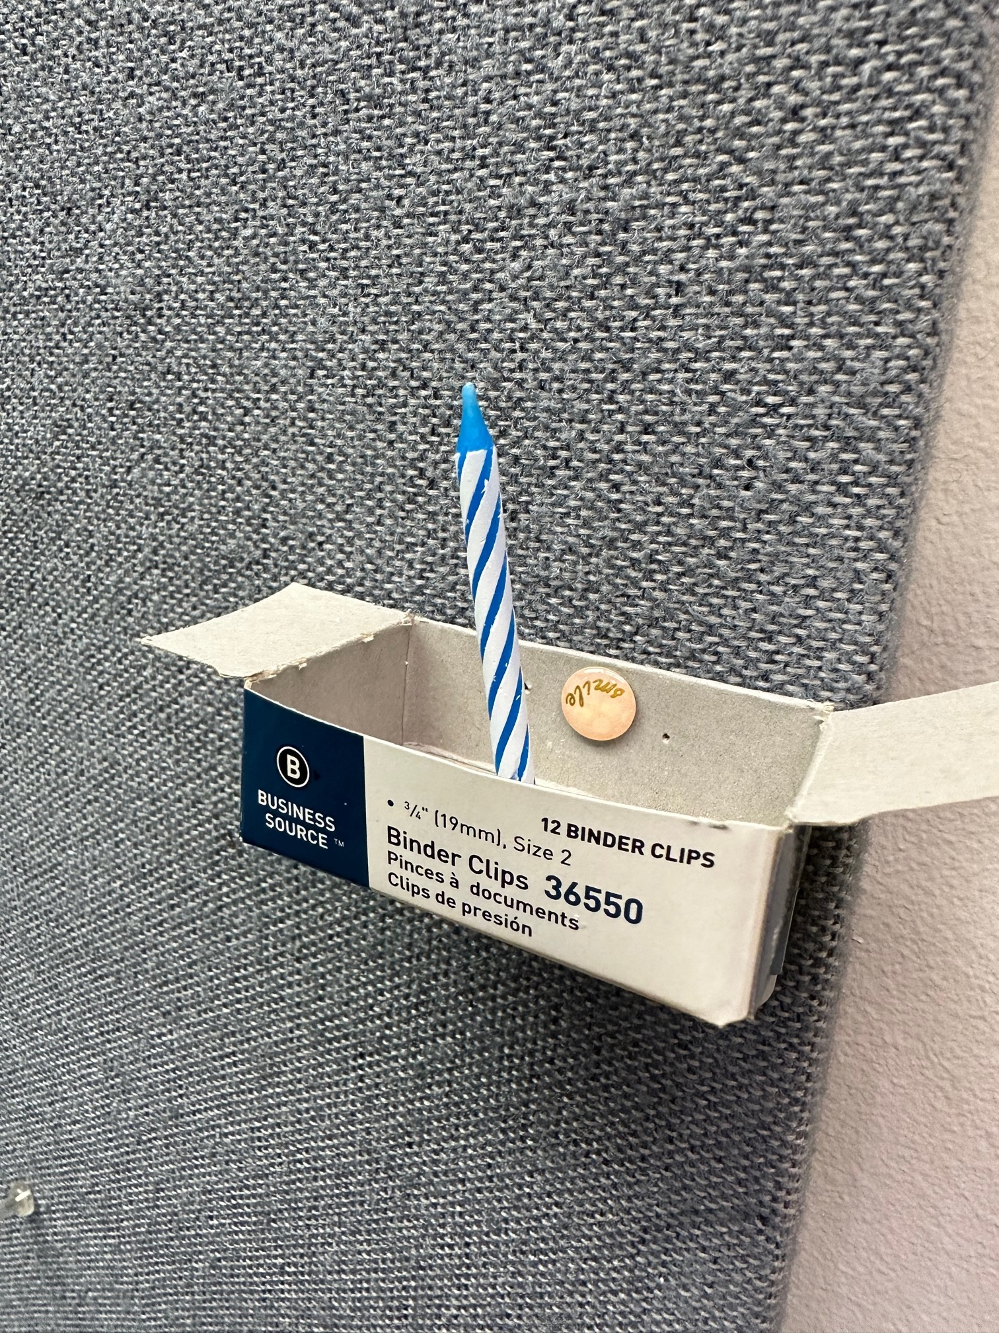

The Water Jug Problem

Background
Another set of factors that influence problem solving are mental sets, in which one keeps trying the same solution that was used in previous problems. This can be particularly true the more the same solution was used. However, just because a solution was useful and efficient in the past it does not mean that it will remain so in the future. But when solutions have been successful in the past, problem solvers can be reluctant to give them up, even when better solutions are available. This can be illustrated with the Water Jug Problem.

In this problem, problem solvers must imagine that they have three jugs that hold different volumes of water and a faucet that they can use to fill the jugs. The goal is to generate a particular volume of water by filling the jugs from the faucet and then pouring them into one another. For example, imagine being given a five cup jug (jug A), a 40 cup jug (jug B), and an 18 cup jug (jug C), and that you must generate 28 cups. You could do this by filling up jug A (5 cups) and dumping it into jug B twice and then by filling up jug C (18 cups) and dumping it into jug B once. You could call this a “2A + C” solution. You can also transfer water from jug to jug to generate particular volumes (e.g., you could create 13 cups of water in jug C by filling that jug and then pouring it into jug A, although in this case that would not help you solve the above problem). Problem solvers work on 10 different problems like this successively. The chart below lists out all of the problems, including the example that you just read.

A “B – 2C – A” solution will work for all of the problems except for #9 (it won’t work for #1 either, which is provided as an example). An “A – C” solution will work for #7, #9, and #11 and an “A + C” solution will work for #8 and #10. Note that, in the earlier problems a complex solution is necessary but in the later problems both a complex and simple solution will work (except for #9, which can only be solved with the simple solution). Research by Luchins (1942) indicates that, when doing all 10 problems, 80% of participants use the “B – 2C – A” solution for problems #7, #8, #10, and #11 and that 64% of people failed to solve problem #9. However, when only doing the last 5 problems, less than 1% of participants used the “B – 2C – A” solution to solve any problems, and only 5% failed to solve problem #9. Participants’ difficulty with problem #9 and reluctance to give up the sub-optimal strategy only when doing all 10 problems (and not when only doing the last 5) demonstrates how their minds get “set” on previously successful solutions and even pass over more efficient solutions in favor of those that have worked in the past.

This problem is somewhat mathematical and for this reason students may enjoy it a little less than the other problems. It will also take them longer because there are essentially 10 problems to solve. Generally speaking we give students 8 to 12 minutes for each of these problems, but that may not be quite enough time for students to complete this one. But even if students cannot quite complete it they still will get a feel for the kind of tasks that have been used to demonstrate mental set. Additionally, this task was featured in the movie Die Hard. A clip of Bruce Willis and Samuel L. Jackson trying to solve this task is available on youtube (https://www.youtube.com/watch?v=2vdF6NASMiE). Showing the clip to students may be an interesting aside after working on this task.

Online description: https://www.transum.org/Software/Investigations/jugs.asp
Solution: https://www.math.tamu.edu/~dallen/hollywood/diehard/diehard.htm

Materials needed for in person version:
- The instruction sheet (below) including the chart.
- The solution sheet.

Instructions
Imagine you have a sink so that you can fill jugs from a tap and pour water into the sink or from one jug into another. The jugs start out empty. When filling a jug from the tap, you must fill the jug to capacity; when pouring the water from a jug, you must empty the jug completely. The goal in problem 1 is to get to 28 cups and you can use three jugs: jug A with a capacity of 5 cups; jug B with a capacity of 40 cups; and jug C with a capacity of 18 cups. To solve this problem, you would fill jug A and pour it into jug B, fill A again and pour it into B, and fill C and pour it into B. The solution to the problem I denoted by 2A+C.

Problem | Jug A | Jug B | Jug C | Desired Quantity | Solution
1 | 5 | 40 | 18 | 28 | 2A+C
2 | 21 | 127 | 3 | 100
3 | 14 | 163 | 25 | 99
4 | 18 | 43 | 10 | 5
5 | 9 | 42 | 6 | 21
6 | 20 | 59 | 4 | 31
7 | 23 | 49 | 3 | 20
8 | 15 | 39 | 3 | 18
9 | 28 | 76 | 3 | 25
10 | 18 | 48 | 4 | 22
11 | 14 | 36 | 8 | 6

Solution to the Water Jug Problem

All problems except # 9 can be solved using the B – 2C – A method (filing B, twice pouring B into C, and once pouring B into A). For problems 2-6 this solution is the simplest; but for problems 8 and 10, the simpler solution of A+C also applies. Problem 9 cannot be solved by the B-2C-A method but can be solved by the simpler A-C. Problems 7 and 11 are also solved more simply by the A-C than by the B-2C-A. Of the participants in the original experiment by Luchin (1942), 83% used the B-2C-A method on problems 7&8, 64% failed to solve problem 9, and 79% used the B-2C-A method for problems 10 and 11.
This is known as the Einstellung effect or mechanization of thought. It is a subset of set effects in that we tend to stick with a particular solution even if it is not the simplest or most efficient. Set effects result when knowledge relevant to a particular type of problem solution is strengthened.

Problem | Jug A | Jug B | Jug C | Desired Quantity | Solution
1 | 5 | 40 | 18 | 28 | 2A+C
2 | 21 | 127 | 3 | 100 | B – 2C – A
3 | 14 | 163 | 25 | 99 | B – 2C – A
4 | 18 | 43 | 10 | 5 | B – 2C – A
5 | 9 | 42 | 6 | 21 | B – 2C – A
6 | 20 | 59 | 4 | 31 | B – 2C – A
7 | 23 | 49 | 3 | 20 | A-C
8 | 15 | 39 | 3 | 18 | A+C
9 | 28 | 76 | 3 | 25 | A-C
10 | 18 | 48 | 4 | 22 | A+C
11 | 14 | 36 | 8 | 6 | A-C

Creativity

Creativity requires solutions that are both novel and useful (Hennesey & Amabile, 2010; Kaufman & Sternberg, 2010). One way that creativity has been investigated is through the incubation effect, which was demonstrated through an experiment by Silvera (1971) known as the Cheap Necklace Problem. In this problem, participants are given four sets of three links of chain and given a set of instructions that it costs 2c to open each link and 3c to close each link. The goal is to create a single circle for 15c. The group that was able to have a half hour break between starting and returning to the problem was most likely to solve this problem because they did not use set effects. Similarly the Nine Dots problem requires participants to literally draw lines outside of the box to solve the problem.

The Cheap Necklace Problem

Background
Set effects, as described above, could be thought of as the opposite of creativity, since they reflect a reluctance to abandon previously used solutions. If this is the case, then identifying ways to avoid set effects may be a fruitful avenue for efficient problem solving. Silvera (1971) described incubation effects as instances where a problem solver avoids a set effect by setting a problem aside for a time and then returning to it; upon the problem solver’s return to the problem old, ineffective solutions are discarded and new, creative ones are utilized. Silvera demonstrated incubation effects with an experiment involving The Cheap Necklace Problem.

The idea behind the Cheap Necklace Problem is that problem solvers are given four sets of three links of chain and are instructed to form them into a complete necklace. It costs 2c to open a link and 3c to close a link. The goal is to complete the necklace for 15c. When Silvera (1971) gave participants half an hour to solve the problem, 55% were successful. However, when participants got breaks while working on the task (half an hour or four hours) more were able to solve the tasks (64% and 85%, respectively). It seemed to be the case that, during the break, participants forgot about the ineffective problem solving techniques they were “set” on and utilized new, innovative strategies that were more successful.

Students tend to be able to solve this one relatively easily. However, it may be helpful to review the how much opening and closing a link costs with them because otherwise they may think they have solved it when they actually haven’t done so according to the rules.

Online description (US only): https://books.google.com/books?id=9P4p6eAULMoC&q=cheap+necklace#v=snippet&q=cheap%20necklace&f=false (click “page 274”)
Solution: https://www.researchgate.net/figure/The-Cheap-Necklace-Problem-CNP-in-its-initial-state-and-the-solution_fig3_48202355

Materials needed for in person version:
- The instruction sheet. Be sure to include the graphic, as this will help students visualize what they need to do.
- The solution sheet
- Optional: It is possible to have participants do this task by simply visualizing the links. However, by purchasing 12 carabineers you can give your students a more hand-on experience. It would also be possible to provide them with 15 pennies so they could keep track of how much money they were spending by altering the links.

Instructions

You are given four separate pieces of chain that are each three links in length. It costs 2¢ to open a link and 3¢ to close a link. All links are closed at the beginning of the problem. Your goal is to join all 12 links of chain into a single circle at a cost of no more than 15¢.

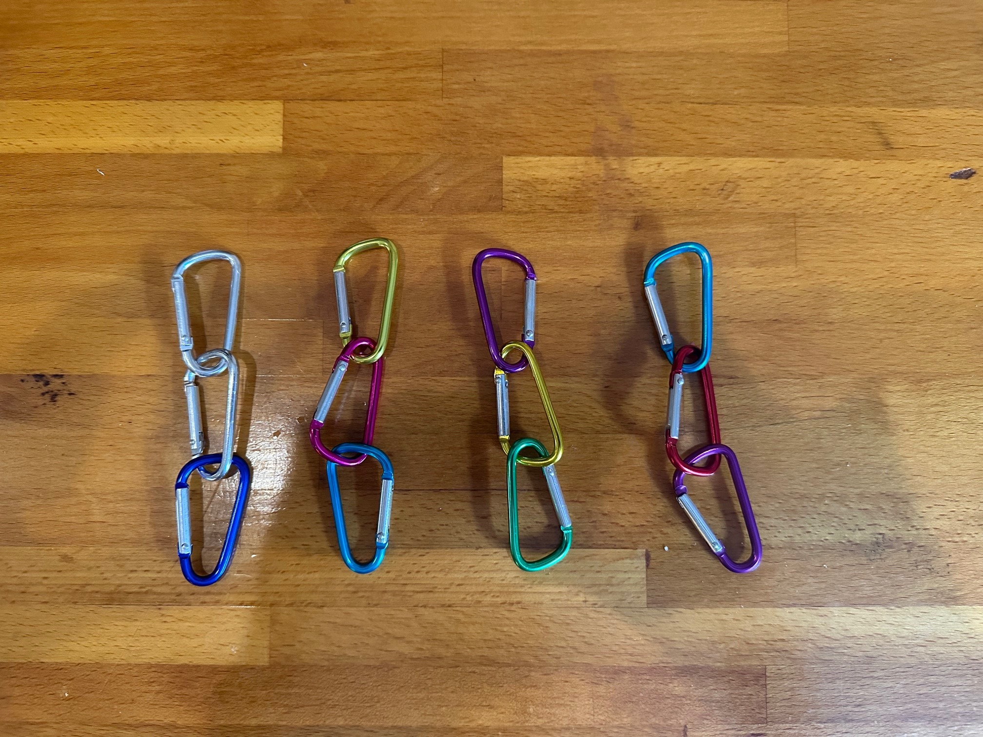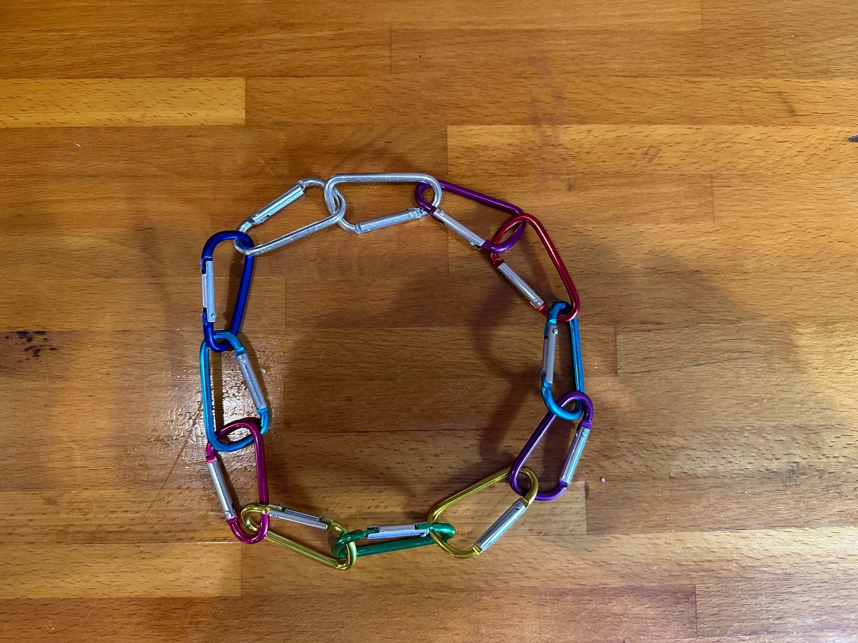
Start End

Solution to the Cheap Necklace Problem

Open all three links on one chain (at a cost of 6¢) and then use the three open links to connect the remaining three chains (at a cost of 9¢) for a total of 15¢

This problem suggests that we can take advantage of ‘incubation effects’ – putting aside a problem for a period of time and upon returning to it, having the solution quickly become apparent. It was originally demonstrated in an experiment by Silveira (1971) in which 1/3 of the participants worked on the problem for half an hour and had a 55% success rate, 1/3 spent a half hour but were interrupted by a half hour break and had a 64% success rate, and 1/3 had a 4-hour break with an 85% success rate.

Start End

The Nine Dots Problem

Background

Another problem that requires a creative solution is the nine dots problem. Here, problem solvers are given a sheet of paper with nine dots arranged in three rows. To solve the problem they must connect all nine dots using no more than four straight lines and they must do this without lifting their pen or pencil from the paper. In order to solve the problem, it is necessary to draw lines that extend beyond the rows of dots themselves. Though the rules say nothing about doing this, it often does not occur to problem solvers that they can draw lines that extend beyond what they perceive to be the boundaries of the problem.

Online description: https://www.youtube.com/watch?v=zs-UtzMstps&t=6s
Solution: https://www.youtube.com/watch?v=Rq3ta6SvlTo

Materials needed for in person version:
- The instruction sheet. It is helpful and efficient to put several dot graphics on the instruction sheet so that your students can draw on it. You may also want to print several of these sheets so that they can start over once they have drawn on all the graphics on their sheet. However, if you are having students cycle through this and several other activities (as we often do) then it is important to make sure that none of them leave sheets with the solution on them laying at the station for this activity.
- The solution sheet

Instructions

Connect all 9 dots by drawing 4 straight lines, never lifting your pen (or pencil) from the page.

Solution to the Nine Dots Problem

Connect all 9 dots by drawing 4 straight lines, never lifting your pen (or pencil) from the page.

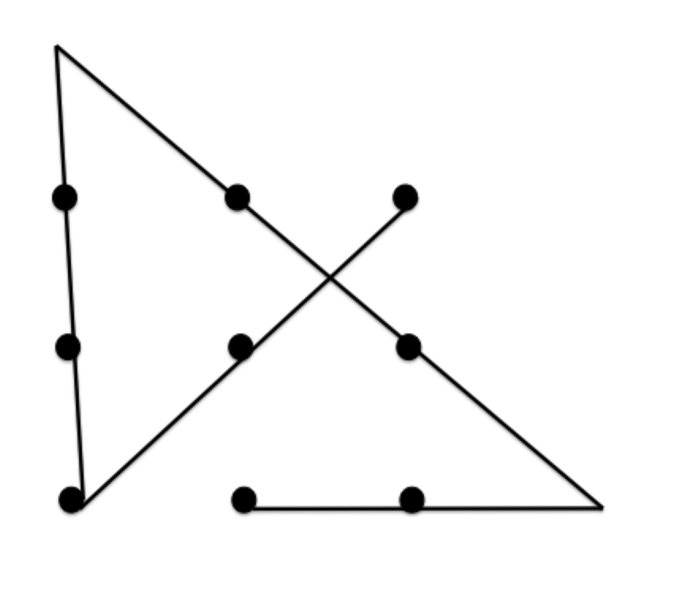

You have to go outside the ‘box’ on this solution. We are often trained to think inside the box or inside the lines. We create an imaginary box constrained by the dots. This solution requires that the lines extend beyond the ‘corners’ of the ‘square’.

References

Anderson, J. R. (2015). Cognitive psychology and its implications (8th ed). New York, NY: Worth Publishers.
Bassok, M., & Novick, L. (2012). Problem solving. In K. J. Holyoak & R. G. Morrison (Eds.), The oxford handbook of thinking and reasoning (pp. 413-432). New York, NY: Oxford University Press.
Benjamin, A. S., & Ross, B. H. (2011). The causes and consequences of reminding. In A. S. Benjamin (Ed.), Successful remembering and successful forgetting: A Festchrift in honor of Robert A. Bjork (pp. 71-88). New York, NY: Psychology Press.
Duncker, K. (1945). On problem-solving. Psychological Monographs, 58(5), i–113. https://doi.org/10.1037/h0093599
Feltovich, P. J., Prietula, M. J., & Ericsson, K. A. (2006). Studies of expertise from psychological perspectives. In K. A. Ericsson, N. Charness, P. J. Feltovich, & R. R. Hoffman (Eds.), The Cambridge handbook of expertise and expert performance (pp. 41-67). New York, NY: Cambridge University Press.
Hennessey, B. A., & Amabile, T. M. (2010). Creativity. Annual Review of Psychology, 61, 569-598. https://doi.org/10.1146/annurev.psych.093008.100416
Jeffries, R. P., Polson, P. G., Razran, L., & Atwood, M. E. (1977). A process model for Missionaries-Cannibals and other river-crossing problems. Cognitive Psychology, 9, 412-440. https://doi.org/10.1016/0010-0285(77)90015-9
Kaplan, C. A., & Simon, H. A. (1990). In search of insight. Cognitive Psychology, 22, 374-419. https://doi.org/10.1016/0010-0285(90)90008-R
Kaufman, J. C., & Sternberg, R. J. (2010). (Eds.). Cambridge handbook of creativity. New York, NY: Cambridge University Press.
Luchins, A. S. (1942). Mechanization in problem solving. Psychological Monographs, 54(6), i–95.https://doi.org/10.1037/h0093502
Silveira, J. M. (1971). Incubation: The effect of timing and length on problem solution and quality of problem processing. Unpublished thesis, University of Oregon.
Ward, G., & Morris, R. (2005). Introduction to the psychology of planning. In R. Morris & G. Ward (Eds.), The cognitive psychology of planning (pp. 1-34). Hove, England: Psychology Press.

