ECP Social Hour at Capitol City Brewing Company

August 7, 2014 from 5-7pm | 1100 New York Avenue NW

All are welcome and encouraged to attend - graduate students, new faculty members, senior faculty members - everyone! Join us in congratulating the 2014 APA ECP Poster Award winner and share your thoughts and experiences on teaching while enjoying a great cold beverage and appetizers.

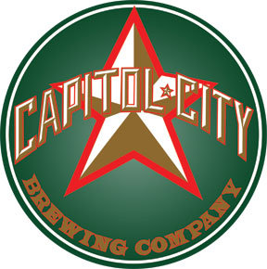

This event is sponsored by the Society for the Teaching of Psychology Early Career Psychologists Committee.

The first round and some snacks are on us!

Be sure to say hi to ECP committee members, Jenny Stiegler-Balfour, Angela Legg and Jordan Troisi when you’re at the social hour.

